Diatoms from Oxford Castle Moat

B A Haggart

Supplementary material to: Munby, J, Norton, A, Poore, D, and Dodd, A, 2019 Excavations at Oxford Castle 1999-2009, Thames Valley Landscapes Monograph 44, Oxford

Report written in 2009

Introduction

Ten subsamples from two monoliths (7177 and 7184) from the lower fills of Oxford Castle moat were made available for diatom analysis.

Methods

Diatom preparation followed standard techniques (Battarbee 1986) with the aim of minimizing disturbance to the samples. Organic material was removed by adding cold 30% hydrogen peroxide to approximately 2g of fresh material. After several days, when the reaction had stopped, the samples were allowed to settle and the supernatant liquid decanted. Clays were removed through repeated addition of distilled water, agitation of the sample, settling for a minimum of eight hours and decanting the supernatant liquid. A random sample was then transferred, using a pipette, to a coverslip and allowed to settle and dry. The coverslip was then fixed on a microscope slide using Naphrax diatom mountant. The slides were systematically counted along ten traverses using an Olympus BX40 microscope at 1000x magnification under phase contrast.

Identifications were made with reference to Hustedt (1930–66), Cleve-Euler (1951–5), Hartley (1996), van der Werff and Huls (1957–64), Kelly (2000), the ADIAC Diatom Image Database (http://rbg-web2.rbge.org.uk/ADIAC/db/adiacdb.htm) and the ANSP Algae Image Database (http://diatom.acnatsci.org/AlgaeImage/). Nomenclature follows Williams et al. (1988), and the current UCL Diatcode checklist.

Results

Diatoms were present in all ten of the samples in variable concentrations and states of preservation. Forty-one taxa were identified, minimum and maximum numbers of taxa per level were 3 and 26 respectively and the mean and standard deviation were 13.1 ± 6.3. The overall species diversity is therefore quite low. Three levels from contexts 7205 and 7195 in monolith 7177 and context 7248 in monolith 7184 had very low numbers of diatoms and are not included in the diatom diagram (Fig. 1). The diatom diagram shows only the more frequent diatoms and is arranged from left to right according to trophic status (Denys 1991) with the first four curves representing unassigned taxa or those with a very wide tolerance of trophic conditions.

The lowermost sample in monolith 7184 came from context 7240, a soft light yellowish brown silt with large fragments of wood and charcoal in a matrix of a blackish clayey silt. The diatom flora comprise 13 species with Cyclotella meneghiniana the most common followed by Navicula capitata v. hungarica. Kelly (2000) considers C. meneghiniana to be a mostly planktonic form, particularly common in rivers, in waters of medium to high conductivity, preferring alkaline and eutrophic conditions. N. capitata v. hungarica suggest a similar pH environment though with nutrient status verging toward more mesotrophic conditions. It is notable that the lowest level contains the best evidence for planktonic free-floating diatoms of all the samples.

The diatom sample from context 7241, a soft mid-brown silt with rare coarse inclusions, was dominated by Gomphonema species, notably G. angustatum and G. parvulum with Nitszschia amphibia also present. These latter two species are eutrophic indicators with G. parvulum a form particularly found in organically polluted conditions in pH environments between 7 and 9 (Kelly 2000).

Context 7247 comprises a soft greyish brown clayey silt with rare grit inclusions. The main forms in this unit are Surirella ovata and Navicula capitata v. hungarica. S. ovata is a freshwater member of a large epipelic genus living on and within sediment typically found in rivers with a pH of 7 and above. Round (1984) however suggests this species can also exist within soil at lower pH values. This level also sees the first occurrence of Rhoicosphenia abbreviata, the only species to be classed a rheophile in the scanned samples.
Context 7197 occurs within the upper part of monolith 7184 and the lower part of monolith 7177. It contains four sub-units, each of which was sampled for diatoms. The lowermost is a mid brown clayey silt with rare subrounded gravel inclusions. Here Gomphonema parvulum dominates, with G. angustatum and Amphora veneta suggesting eutrophic, organically polluted water. Lying above is a coarser unit of sub-rounded to rounded gravel in a silty brown matrix with partially sorted gravel inclusions. Lemnicola hungarica dominates the diatom flora with Amphora veneta, Gomphonema parvulum, G. angustatum and Amphora copulata in decreasing frequencies.

Very few diatoms are known to inhabit specific environments, but according to Buczkó (2007) L. hungarica is an epiphytic form usually found attached to the roots of the common duckweed (Lemna minor) and it also favours the greater duckweed (Spirodela polyrrhyza), fat duckweed (L. gibba) and rootless duckweed (Wolffia arrhiza) but not, apparently, the ivy-leaved duckweed (L. trisulca).

Goldsborough (1993) describes a restricted diatom flora from freshwater Canadian ponds dominated by duckweed which includes Lemnicola hungarica, Achnanthes copulata, A. veneta, Epithemia adnata, E. turgida, Gomphonema angustatum, G. parvulum, Navicula cryptocephala, Nitzschia amphibia, N. palea and Surirella ovata which is very similar to that within the partially sorted gravel of context 7197. Reasons for the low diversity encountered could be due to low light levels (<1 ° of ambient) and wide spatial and temporal variations in the vertical profiles of temperature and dissolved oxygen and nutrients within and beneath duckweed mats.

Lemna sp. seeds were recovered from moat contexts 7283 and 7294 (Pelling in Munby et al. 2019) but in general the Lemnaceae rarely produce flowers and their seeds would be underrepresented in the plant macrofossil assemblage. The diatom flora suggests duckweed may have been an important component of the surface water during deposition of context 7197 sediments. Several species of the family are indicative of still water but Lemna minor and L. gibba can tolerate slowly flowing water and even the occasional spate (Haslam et al. 1975).

This unit contains partially sorted gravel within a brown silt matrix which might be taken initially to suggest some degree of water movement. However, using the Hjulstrøm curve, a graph used by hydrologists to determine whether running water will erode, transport, or deposit sediment, it suggests that to erode very fine gravel of between 2–4mm in diameter, a flow of at least 0.8m/sec would be needed, which is considered unlikely. At these current velocities most silt size particles would also be entrained and flushed from the system. A more likely suggestion for the gravel sorting may be bank collapse into standing water.

The upper two sub-units of context 7197 are finer in nature. Above the gravel is a friable dark brown organic silt with occasional bright blue mottling succeeded by a soft mid brown silty clay with rare grit inclusions. Amphora veneta is dominant in the first sub-unit with 87% total valves scanned and the previously abundant Lemnicola hungarica was not recorded. A. veneta is described by Van Dam et al. (1994) as alkalibiontic, occurring exclusively at pH values over 7, so it is possible an increase in pH may be reflected here. The uppermost sub-unit sees the return of Lemnicola hungarica and other species such as Amphora veneta, Hantzschia amphioxys and Gomphonema parvulum suggestive of a restoration of duckweed mats on the water surface.

Other findings

During scanning for diatoms, dendriform phytoliths were noted in all but the lowermost sample. They were most abundant in monolith 7177, context 7197, and a photograph of one example is given in Figure 2.

A literature search suggested similarity to cereal inflorescence bract phytoliths (Ball et al. 1996; 1999; Hodson et al. 2008). A key provided in Ball et al. (1996) suggested most belonged to Triticum aestivum, based on length and narrowest width. This would be in accord with the finding of a charred grain of a free-threshing wheat from moat context 7166 (Pelling in Munby et al. 2019). Oxygen, silicon and carbon isotope data have recently been extracted from cereal phytoliths, which may open up a future avenue of research for environmental reconstruction (Hodson et al. 2008).

Conclusions

Diatoms were found in all samples, the best preserved and most diverse from context 7197. Most diatom species encountered are indifferent to flowing water so no definitive answer can yet be given regarding whether the moat was a closed or open system, though low overall species diversity might argue for a closed system. Better integration of sediment description perhaps with particle size analysis along with the diatom and plant macrofossil information may provide a way forward.

Initially the free-floating planktonic form Cyclotella meneghiniana indicates clear water conditions, thereafter the rise in Lemnicola hungarica suggests the formation of floating duckweed mats which would have severely restricted light penetration and species diversity.

Undoubtedly the diatoms suggest the moat contained water with a pH above 7. Eutrophic conditions persisted throughout with perhaps increased eutrophic conditions periodically through context 7197.

References

Ball, T B, Gardner, J S, and Anderson, N, 1999 Identifying inflorescence phytoliths from selected species of wheat (Triticum monococcum, T. dicoccon, T. dicoccoides and T. aestivum) and barley (Hordeum vulgare and H. spontaneum) (Gramineae), American J Botany 86, 1615–23
Ball, T B, Gardner, J S, and Brotherson, J D, 1996 Identifying phytoliths produced by the inflorescence bracts of three species of wheat (Triticum monoccocum L., T. dicoccon Schrank., and T. aestivum L.) using computer-assisted image and statistical analysis, J Archaeol Sci 23, 619–32
Battarbee, R W, 1986 Diatom analysis, in Handbook of Holocene palaeoecology and palaeohydrology (ed. B E Berglund), 527–70, Chichester
Buczkó, K, 2007 The occurrence of the epiphytic diatom Lemnicola hungarica on different European Lemnaceae species, Fottea, Olomouc 7, 77–84
Cleve-Euler, A 1951–5 Die Diatomeen von Schweden und Finland, Kungl Svenska Vetensk Akad Handl Ser. 4, 2:1, 1-163. 3:3, 1-153. 4:1, 1-158. 4:5, 1-255. 5:4, 3-231
Denys, L, 1991 A check-list of the diatoms in the Holocene deposits of the western Belgian Coastal Plain with a survey of their apparent ecological requirements. I. Introduction, ecological code and complete list, Belgische Geologische Dienst Professional Paper 246
Goldsborough, L G, 1993 Diatom ecology in the phyllosphere of the common duckweed (Lemna minor L.), Hydrobiologia 269/270, 463–71
Hartley, B, 1996 An atlas of British diatoms, Bristol
Haslam, S, Sinker, C, and Wolseley, P, 1975 British water plants. An illustrated key based on the vegetative features of vascular plants growing in fresh water, with notes on their ecological and geographical distribution, Field Studies 4, 243–351
Hodson, M J, Parker, A G, Leng, M J, and Sloane, H J, 2008 Silicon, oxygen and carbon isotope composition of wheat (Triticum aestivum L.) phytoliths: implications for palaeoecology and archaeology, J Quaternary Sci 23, 331–9
Hustedt, F, 1930–66 Die Kieselalgen Deutschlands, Oesterreichs und der Schweiz unter Berucksichtigung der ubrigen Lander Europas sowie der angrenzenden Meeresgebeite. In Dr. L. Rabenhorsts Kryptogamen-Flora von Deutschland, Oesterrech und der Schweiz 7, Parts 1-3
Kelly, M, 2000 Identification of common benthic diatoms in rivers, Field Studies 9, 583–700
Round, F E, 1984 The ecology of algae, Cambridge
van Dam, H, Mertens, A, and Sinkeldam, J, 1994 A coded checklist and ecological indicator values of freshwater diatoms from the Netherlands, Netherlands J Aquatic Ecology 28, 117–33
Van Der Werff, A, and Huls, H, 1957–74 Diatomeenflora van Nederland. 8 parts published privately by A. Van Der Werff, Westzijde, 13a De Hoef, (U), The Netherlands

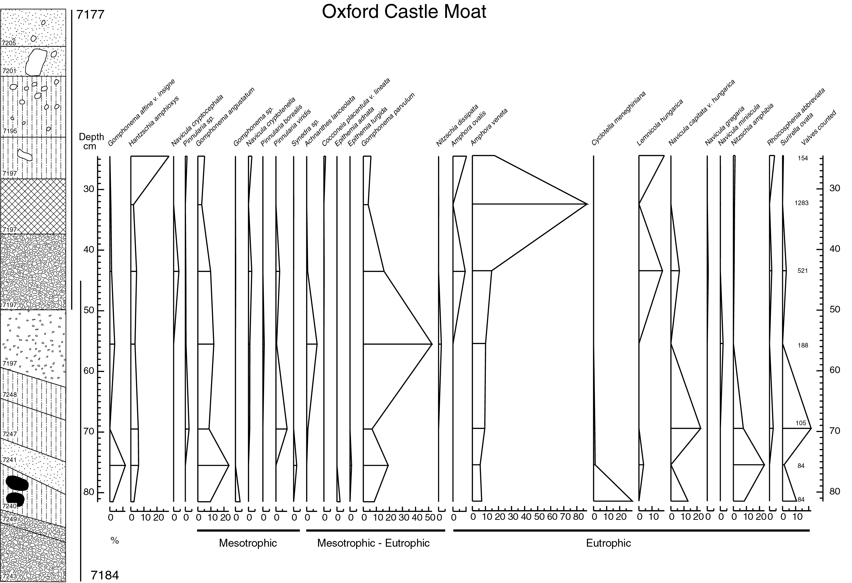
Fig. 1. Diatom diagram
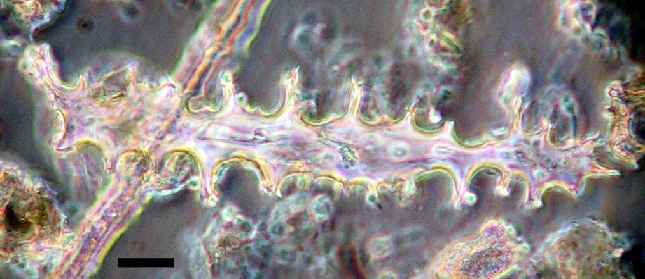
Fig. 2. Possible cereal inflorescence bract phytolith from context 7197. Magnification x 1000 under phase contrast, Bar = 10µm

