

Managing Lithic Scatters and Sites
Archaeological guidance for planning authorities and developers
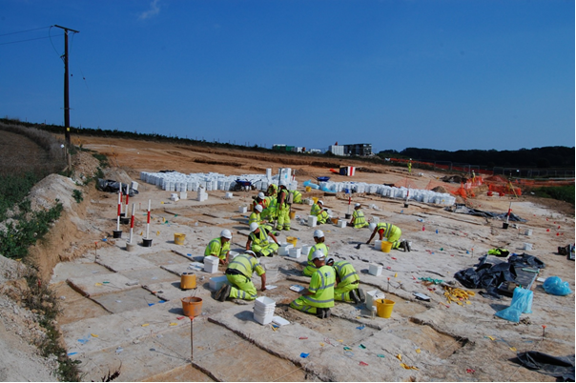
Managing Lithic Scatters and Sites: Archaeological guidance for planning authorities and developers
Summary
Lithic scatters and sites are an important archaeological resource that can provide valuable insights into prehistory. Most commonly found as scatters of worked stone, usually suspended in modern ploughsoil deposits, which have been disturbed from their original archaeological context through ploughing. Undisturbed lithic sites can also be found through further evaluation and excavations, where lithics have been sealed by cover deposits or preserved in sub-surface features/horizons. Lithic scatters can represent a palimpsest of activity, sometimes containing several technologies from different archaeological periods. Consequently, the value of lithic scatters as a source for investigating past behaviour has often been undervalued. However, in many cases, especially for sites dating from the Palaeolithic period through to the Bronze Age, lithic scatters are likely to represent the only available archaeological evidence of past human activity and subsistence strategies. By studying and understanding their formation, spatial distribution and technological attributes, we can get closer to understanding the activities of the people who created these artefacts.
Lithic scatters are often perceived as being particularly problematic from a heritage resource and development management perspective, because the standard archaeological methodologies presently employed are often not sufficiently subtle to ensure their effective identification and characterisation (Last 2009). This can either lead to an unquantified loss of important archaeological evidence, or the under-estimation of the magnitude of a site’s scale and importance, leading to missed research opportunities or, in a planning/development context, potentially avoidable expense, delay and inconvenience. The need for the development of suitably sensitive archaeological methodologies, geared to identifying and characterising lithic scatters and sites, has recently been identified as a key priority (eg ibid; Bond 2011; Blinkhorn and Milner 2014).
This document aims to provide guidance on appropriate techniques to extract the most from the lithic resource at all stages of the project from desk-based assessment and fieldwork investigations to post-excavation. It is intended for everyone involved in working with lithic material, ranging from developers to those involved in community based projects. As such, it considers key themes relating to the definition and significance of lithic scatters and sites; the means to identify, assess, evaluate and excavate them; and their mitigation and management. Therefore, it encompasses a broad range of advice and techniques that can be applied to a wide variety of project types and budgets.
Additional methodological detail and technical advice is also provided in Appendix 1 – Case Studies.

Introduction
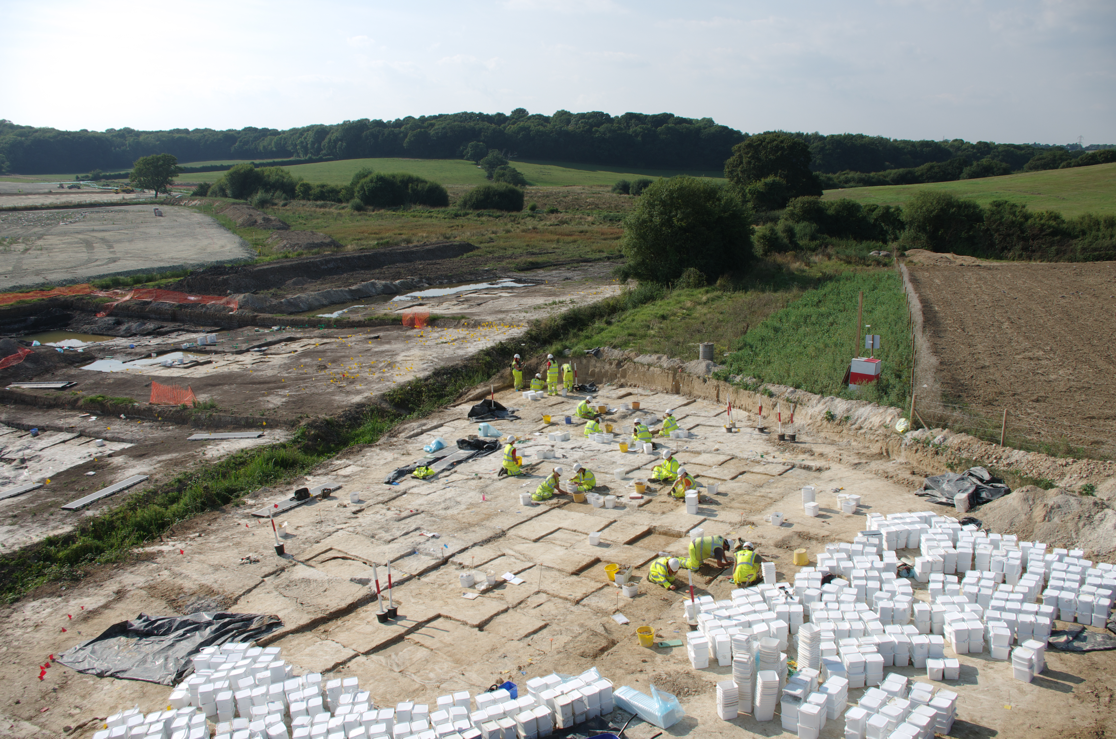
Fig. 1: Excavation of lithic sites using both grid squares and GPS plotting of lithics along the Bexhill to Hasting Link Road, East Sussex. The site shown in the image was one of over 200 individual lithic sites and scatters which were identified along the valley edges sealed by thin layers of alluvium and peat.
It is over 18 years since the guidelines for Managing Lithic Scatters (2000) were first published to help planning authorities and developers understand some of the key issues relating to the investigation of lithic scatters. That document raised awareness of the significance of the lithic resource, highlighting that in many regions assemblages of worked stone from ploughzone contexts were the only available archaeological evidence for past occupation. As such, the archaeological value of lithic scatters for understanding human prehistory is high. Since the document’s publication there have been a number of major lithic discoveries that have helped to develop new techniques for locating, managing, excavating and analysing sites within the commercial and research sectors (eg Chan 2011; Billington 2016; Brown et al. forthcoming; Oxford Archaeology forthcoming; see Figure 1). The use of geoarchaeological deposit modelling has benefitted the detection of lithic sites (Appendix 1: case study 3). The use of deposit modelling has also aided understanding of the context of discovery and interpretation of open-air Late Upper Palaeolithic (LUP) sites (eg Harding et al. 2014). In spite of these developments and advances in lithic studies, some curators and heritage professionals are still cautious over the logistical and financial challenges associated with the investigation and management of lithic sites, ultimately resulting in the undervaluing of this significant heritage resource (Bond 2011).
This updated guidance on managing and dealing with lithic sites, both within and outside the planning process, aims to ensure that they are valued appropriately by raising awareness of their significance and vulnerability. It has been prepared with a wide range of interested parties dealing with lithic sites in mind, especially those from a planning or heritage conservation background. The guidance conforms to the National Planning Policy Framework (NPPF) in order to provide advice for assessing, evaluating, mitigating and researching lithic sites. The information contained in this document is augmented by a selection of case studies which are presented in a separate volume (Appendix 1). The case studies outline a range of applications involved in the prospection, recording, excavation, analysis, interpretation and management of the lithic resource, in order to complement themes addressed in this document. This guidance should also be read in conjunction with relevant Historic England guidance documents such as the scheduling selection guide Sites of Early Human Activity (2018 https://historicengland.org.uk/images-books/publications/dssg-sites-early-human-activity/), advice on geoarchaeological deposit mapping and modelling (Historic England 2015a) and Historic England’s documents on good practice in planning (Historic England 2015b), and forthcoming guidance on deeply buried Palaeolithic sites: Curating the Palaeolithic.
This guidance is designed to be an easily accessible document which describes the steps and procedures recommended for the identification, investigation and management of lithic sites. What constitutes a lithic site and the main terms used to describe and define them are covered in the introduction. How to assess the potential of a study area to contain a lithic site, or sites, is discussed in the first section. The second section outlines the significance of lithic sites, their protection and methods for defining their potential research value, when needed. It also discusses the range of evaluation procedures which can be applied once the lithic resource of an area has been characterised, and summarises the analytical methodologies which can be applied when excavating and researching a lithic site. Section three discusses the management and monitoring of lithic sites on arable land and other vulnerable locations. The final section provides further information on historic environment records, an informative reading list and a glossary which provides details of key terms and specialised meanings.
Definition of lithic sites and key terms
There is considerable debate regarding the nomenclature that should be used to best define displaced lithic sites devoid of a secure archaeological context and those that remain in situ. For the purpose of this guidance, and in keeping with the original, the former are referred to as lithic scatters whilst those sites retaining contextual significance are described as undisturbed or in situ lithic sites. By in situ we mean that the lithic scatter retains its spatial integrity so that it is possible to interpret the activities behind its formation, rather than being found within its exact location as it was originally deposited thousands of years ago.
Lithic scatters are assemblages of worked stone displaced from their original context and predominantly contained in subsoil and/or topsoil deposits. (Appendix 1: case study 2). In some instances, they can comprise a ploughzone assemblage derived from still surviving sub-surface features which has been displaced by the ongoing truncation of the lithic-bearing deposits. However, due to the complete destruction of once-associated features and/or palaeolandsurfaces, they are often the only evidence for past activity which is, frequently, confined to a layer of ploughsoil. In this respect, lithic scatters are found in geographic locations, particularly lowland regions, where ploughing and other forms of ground disturbance are ongoing. The original, discrete lithic site is continually being reworked, sometimes on both the vertical and horizontal plane, creating dispersed scatters (Appendix 1: case studies 2 and 4). Consequently, many lithic scatters incorporate material from sites that were originally not connected in space and time.
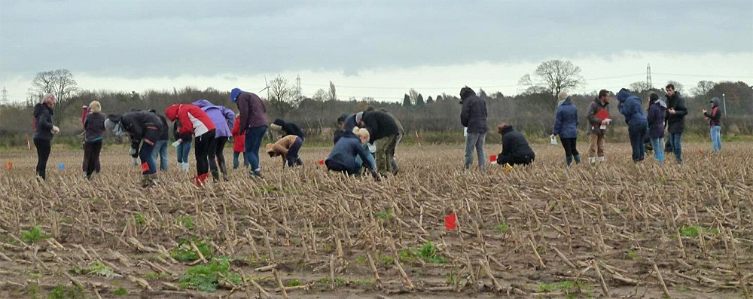
Fig. 2 Fieldwalking by a group of local volunteers of a lithic scatter in Cumbria.
Thus, the majority of lithic scatters are mixed assemblages comprising several lithic technologies from different archaeological periods (Appendix 1: case studies 2 and 4). Consequently, the value of lithic scatters as a source for investigating past behaviour has been questioned. They are often characterised as being of low interpretive value and are marginalised both in academic studies and in the wider context of protecting and managing the historic environment. However, in many cases – particularly for sites dating to early prehistory when other diagnostic artefacts are extremely rare – lithic scatters are likely to be the only available archaeological evidence of past occupation and are therefore an important and significant resource.
Lithic scatters form a vast body of archaeological evidence. They are regularly identified and recorded in fieldwalking surveys undertaken during commercial archaeological projects and community research (Appendix 1: case studies 2, 4 and 5; see Figure 2). However, their study rarely contributes to contemporary accounts of regional and national archaeological landscape developments (Bond 2011). Well-preserved sites with undisturbed lithic assemblages, especially those with associated faunal remains and/or palaeoenvironmental evidence, form the foci for such research. As a consequence, policy makers, fieldworkers and curators are not equipped with the information necessary to make informed decisions concerning the investigation, management and protection of the wider archaeological landscape as defined by lithic scatters. The study of lithic scatters potentially has the means to address this imbalance. Indeed, when well-designed and appropriate research strategies are applied to the study of lithic scatters they can provide high-quality evidence, allowing detailed interpretation and providing significant academic value (Appendix 1: case studies 2, 4 and 5).
Lithics associated with sub-surface features retain their archaeological significance and represent an undisturbed lithic site (Appendix 1: case study 6). In addition, undisturbed sites can include lithic assemblages associated with buried palaeolandsurfaces or horizons (Appendix 1: case studies 3 and 7). These sites are often sealed by superficial geological deposits and whilst they may have been subjected to post-depositional disturbance and can contain mixed technologies, they still retain a high archaeological value; in the case of Palaeolithic sites they can be of national and/or international significance (see section 2). Undisturbed lithic sites that are not associated with sub-surface features, for example those that survive within a buried soil horizon, are classified as sites without structures. The archaeological significance of such sites is considered in Historic England’s scheduling selection guide Sites of Early Human Activity (2018).
Lithic assemblages derived from secure archaeological deposits are comparatively rare in relation to surface scatters. Undisturbed assemblages can be derived from a variety of contexts, for example archaeological features and buried soils, and from a variety of geomorphological settings, such as valley, coastal and upland environments (Figure 3). Given that undisturbed lithic assemblages are recovered from secure archaeological contexts and are, therefore, associated with a specific place and time, they are perceived as having greater potential for detailed study.
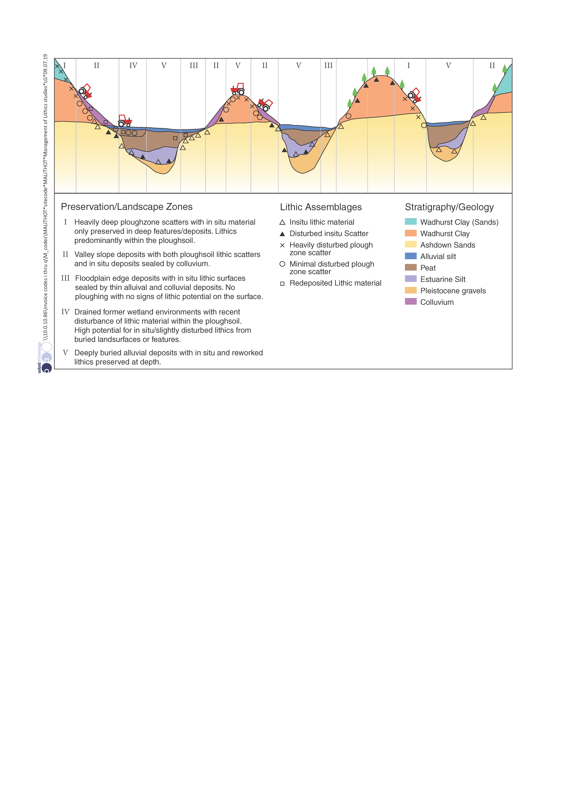
Fig. 3: Schematic cross-section of lithic preservation within a valley sequence.
Lithic sites can contain core reduction material, debitage (primary technology) and tools (secondary technology) produced during knapping (Inizan et al. 1992; Butler 2005). Many tools are diagnostic and can be ascribed a function and date, such as arrowheads, some scrapers and axe/adzes (Figure 4). As such their general use can be identified. Moreover, microwear analysis (Appendix 1: case study 6) has shown that apparently unmodified blades and flakes were also used. Stone tools were utilised in a variety of tasks including hunting, butchery, woodworking, making other tools and the processing of plant and animal resources. The waste generated during tool manufacture can also be defined by its technological character and, if sufficient is present within a given assemblage, its analysis can also inform on site function, date and landscape context (Appendix 1: case study 5). Essentially, different tool types were produced during different periods in prehistory; consequently, the waste produced during their manufacture changed in technological character making this material distinctive to specific periods too.
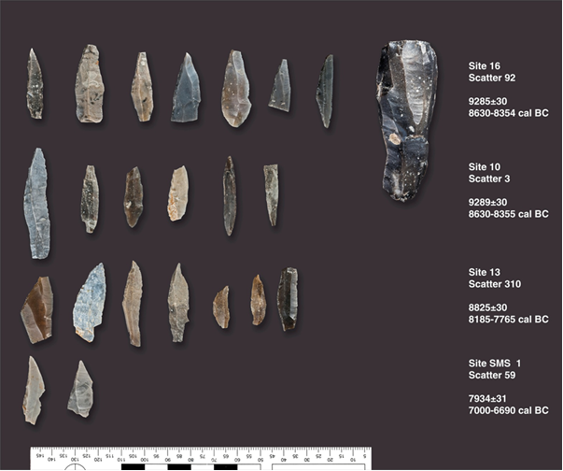
Fig. 4 Lithic analysis is fundamental to the study of worked stone assemblages. It is an essential part of understanding the process of the chaîne opératoire, which describes the series of events and social actions behind the stages of stone working from procurement and manufacture through to discard and recovery during archaeological investigations. The analysis of core reduction strategies can inform on the different ways that nodules were worked. Through a detailed analysis of core types in conjunction with an assessment of the metrical and technological attributes of the blade and flake debitage, such as platform features, termination types and dorsal scar configurations, statements can be made about the date and function of an assemblage (Appendix 1: case studies 2, 4 and 5).
While the focus of this discussion has been on early prehistoric lithic sites it should be acknowledged that they can also evidence Late Bronze Age and later activity. The continuation of utilitarian domestic industries is likely to have continued into the Iron Age (Humphrey and Young 1999), whilst specialised industries continued into later periods, including the manufacture of tools for shale-working (notably in Iron Age and Romano-British Dorset), post-medieval gunflint production and the dressing of flint for building stone in the medieval and post-medieval periods.
Mention should also be made of lithic assemblages held in museum archives. These mainly consist of collections of worked stone recovered during archaeological projects, both commercial and research led, and deposited as part of the project archive. In addition, many museums also hold legacy collections many of which represent assemblages of worked stone collected in the nineteenth and twentieth centuries. While the majority of the museum and legacy collections are without context, and in some instance are unprovenanced, they can provide an invaluable resource, much of which has seen very little analysis and investigation. As such their study, when integrated into broader research enquiries, can provide supplementary information on intra- and inter-site associations and landscape value (Appendix 1: case studies 1, 2 and 4).

Lithic desk-based assessment
The NPPF and Planning Practice Guidance (PPG) set out the government’s planning policies for England and how these are expected to be applied to the management of the historic environment. As part of these conditions, a desk-based assessment (DBA) may be commissioned (CIfA 2014a; Historic England 2015b, 3).
As the majority of lithic sites and scatters are recognised as non-designated heritage assets they should be included in DBAs. Information on known lithic assemblages is accessible from a number of sources. The most significant of these are county-based historic environment records (HERs) (see section 4). All local authorities in England should maintain or have access to an HER which is a searchable record of known archaeological sites and monuments, other heritage assets such as listed buildings and structures, and local records and archives (Historic England 2015b). Data held by some HERs are also linked to Geographical Information Systems (GIS) and can be searched online via the Heritage Gateway (see below), and most local authority offices have facilities for visiting HERs in order to personally examine records. Searches for heritage assets within a designated geographical area can also be requested and undertaken by HER staff. HERS provide an invaluable resource relating to lithic sites, but it is essential to recognise that whilst the records have great potential for defining lithic sites and scatters within a study area, they also have limitations (Billington 2016; Appendix 1: case study 1) and these are discussed below.
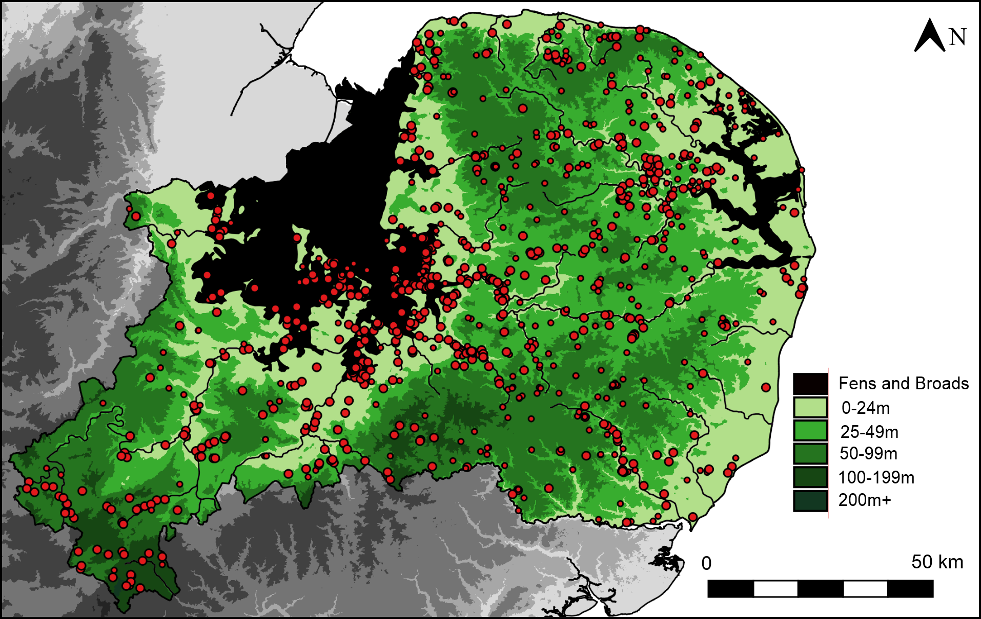
Fig. 5: Distribution of accurately located findspots of Mesolithic flintwork from a study area in Eastern England. Through the study of lithic site distributions and their relationship with river valley and upland areas, it is possible to look for trends and patterns in their location.
HERs are a useful tool for identifying the potential for lithic sites and scatters within a DBA study area, but they are not exhaustive and supplementary information can be found at other sources:
- Heritage Gateway is an online portal for querying some HER records (http://www.heritagegateway.org.uk/Gateway/CHR/)
- The National Heritage List for England (www.HistoricEngland.org.uk/listing/the-list) holds details of scheduled monuments. Lithic assemblages can occasionally be part of a scheduled monument, for example when they form part of a multi-period site
- The Portable Antiquities Scheme (PAS) (https://finds.org.uk/) was ostensibly set up to record metal detecting finds, but incorporates other artefacts, including lithic finds, and the scheme’s database links this information to HERs. The potential and limitations of the PAS database are discussed in section 4
- Pastscape (https://www.pastscape.org.uk/default.aspx) holds information on archaeological sites and other heritage assets derived from Historic England’s National Record of the Historic Environment (NRHE)
- Archaeology Data Service (http://archaeologydataservice.ac.uk/) is a digital repository for heritage data, including grey literature reports on archaeological investigations. This service also holds digital copies of documents relating to the record of Palaeolithic and Mesolithic settlement including The English Rivers Project (TERP) (https://archaeologydataservice.ac.uk/archives/view/terps_eh_2009/) and the Palaeolithic and Mesolithic Lithic Artefact (PaMELA) database https://archaeologydataservice.ac.uk/archives/view/pamela_2014/)
- Local museum collections, journal and specialist publications such as those of the Prehistoric Society and the Lithic Studies Society, and grey literature and publication reports held by archaeological contractors. Many older publications and journal articles can be found on-line on publisher’s websites and portals such as Researchgate (https://www.researchgate.net/) and Academia.edu (https://www.academia.edu/)
Integral to any DBA is an assessment of the significance and setting of the identified heritage assets. The examination of HERs and other sources can produce data on the geographic location of known lithic sites within a given study area, but important information relating to the resource’s landscape value is unlikely to be recorded. The spatial relationship of lithic sites, be they remains contained in the ploughzone or known from excavations, can be meaningful (Figure 5). Lithic sites have great potential to be associated with others within a regional landscape context (Appendix 1: case studies 2, 4 and 7), or, as in the case with raw material extraction sites, on a national scale (Appendix 1: case study 5), and they can relate to wider social dynamics such as patterns of movement and/or resource procurement (Appendix 1: case study 6). In this respect, the role of lithic sites, particularly surface scatters, within a landscape context is of significance and consideration should be given to how a site, or a group of sites, can be contextualised within landscape characterisations and used to influence decisions during the planning process and heritage management.
HER data and information derived from other sources can also be limited in terms of characterising the geomorphological and the geological setting of lithic sites. This is important as such information may inform on the potential existence of unknown lithic sites within a DBA study area, particularly sites sealed by cover deposits such as alluvium, colluvium or drift deposits. For example, alluvial deposits associated with valley systems and coastal locations may mask prehistoric sites, especially those dating to the Palaeolithic and Mesolithic (Appendix 1: case studies 3, 6 and 7). For further information on buried Palaeolithic sites see the forthcoming Historic England guidance Curating the Palaeolithic.
The analysis of aerial photographs and LiDAR (https://historicengland.org.uk/research/methods/airborne-remote-sensing/lidar/) carried out in conjunction with a walkover survey, often commissioned as part of a DBA, can be a useful tool for characterising the landscape of a study area. Additionally, spatial analysis of lithic sites, relevant monuments and palaeoenvironmental data can be used to develop a broader picture of the prehistoric occupation of an area, and their distribution can also be used to predict the presence of unknown lithic sites.
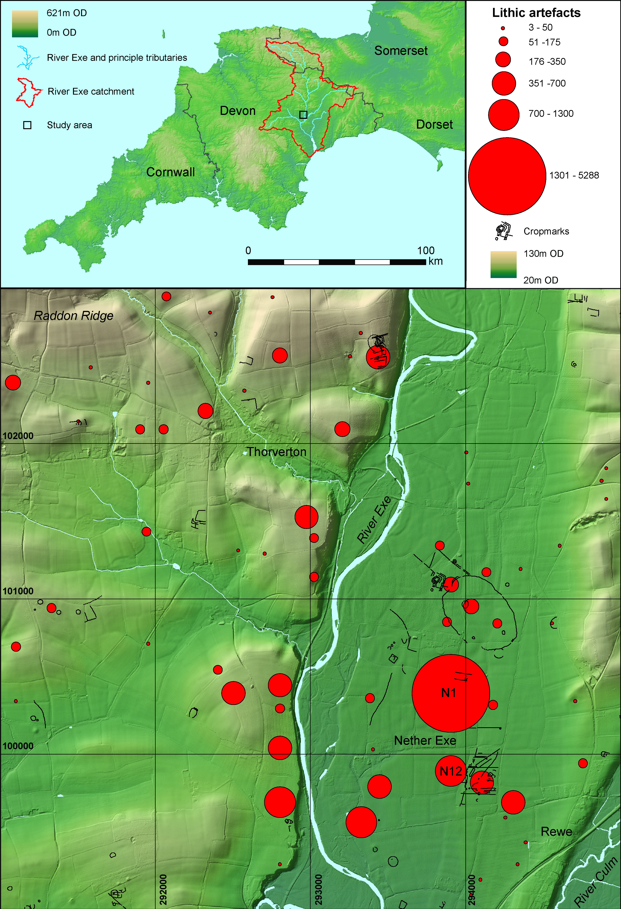
Fig. 6: Lithic scatters and monuments in the Lower Exe Valley, Devon, illustrating the relationship between different landscape elements. Topography derived from 90m SRTM topography data courtesy of CGIAR http://srtm.csi.cgiar.org, and 1m LiDAR digital terrain.
Predictive modelling and/or geoarchaeological deposit modelling can benefit such studies and can be extremely useful for investigating the potential for the presence of unknown lithic sites within deeply buried environments. In essence, predictive modelling seeks to identify and define the distribution of archaeological sites across the contemporary landscape based on known patterns of activity. In this sense, the known distribution of lithic sites within a study area along with other related sites and monuments can be combined with geomorphological and environmental data as a baseline to predict the location and position of as yet unidentified sites (Carey et al. 2017; see Figure 6). Geoarchaeological deposit modelling uses geological data gathered from subsurface investigations such as geotechnical test pitting, borehole surveys, remote sensing and specific types of geophysical survey techniques (eg electro-magnetic ground conductivity survey) and surface data relating to palaeotopography and superficial geology to create 3D reconstructions of sedimentary sequences and palaeolandscapes (Historic England 2015a, https://historicengland.org.uk/images-books/publications/geoarchaeology-earth-sciences-to-understand-archaeological-record/heag067-geoarchaeology/; Appendix 1: case study 3). Such sequences may include buried landscapes or archaeological horizons with associated lithic assemblages which often have a strong potential to include preserved organic remains. For additional information on geoarchaeological modelling and its role in lithic site identification, see the forthcoming Historic England document on Deposit Modelling Guidance.

Significance, mitigation and research
Significance
The significance and setting of lithic scatters and sites within the historic environment should be considered in relation to the policies and guidance set out in the NPPF and PPG (Historic England 2015b; 2017). The aim of identifying the heritage significance of a lithic site is to justify its consideration in management plans, whether they relate to a development context or a publicly funded project. Within a development context assessment of the significance of a heritage asset is usually undertaken during early stages of consideration of planning proposals. For some assets, such as designated monuments and structures, the significance of the site is reasonably well understood. However, for most lithic sites a staged approach to assessing significance may be required (Appendix 1: case studies 2 and 5).
A DBA may have identified the presence or potential of lithic sites, and assessed the wider landscape value of the resource within and beyond the confines of the development or research area (CIfA 2014a; see section 1; see Figure 7). Consideration of the site’s spatial relationship with known prehistoric archaeological sites and monuments will have informed on its potential value within known settlement and land-use patterns (Appendix 1: case study 4). This will provide essential information for assessing the site’s significance and setting. However, information relevant to understanding site-specific attributes and character is often required to further define significance. This is usually gained through an archaeological evaluation of the site (see below), using an appropriate strategy, detailed in a written scheme of investigation (WSI) (Historic England 2015b, 10-11).
The evaluation should benefit the understanding of a lithic site’s extent, technological composition and date range, function, spatial pattern and, potentially, its geo-archaeological context (Historic England 2018; see section 3; Appendix 1: case study 2). At this stage further evaluation may be proposed. For example, the results of the evaluation strategy may have identified discrete distributions of lithic artefacts within the wider extent of the site. This may suggest the presence of buried structures or features from which the worked stone could have derived. In this instance, further investigation may include trial trenching or test pit survey of the site area in order to detect potential sub-surface archaeological features.
Mitigation
By drawing on information recorded during desk-based analysis and field evaluation the significance of a site can be defined and considered alongside the impact from development. From this, strategies relating to the protection and management of the site can be formulated. Within a development context this will consider a range of measures to mitigate the impact of development proposals on the lithic resource (Appendix 1: case study 7). In some circumstances the option to preserve a site in situ is a practicable solution, and it may be possible for the site to be preserved through design and management. In others, depending on the significance of the site, further excavation may be deemed a suitable mitigation against development impact. Where a site is sealed by sedimentary overburden, preservation in situ will have to be carefully managed in order for the site to retain its secure context (including maintaining water levels). There is a danger that if this is not undertaken effectively it will eventually become a site without structures (Historic England 2018).
Research
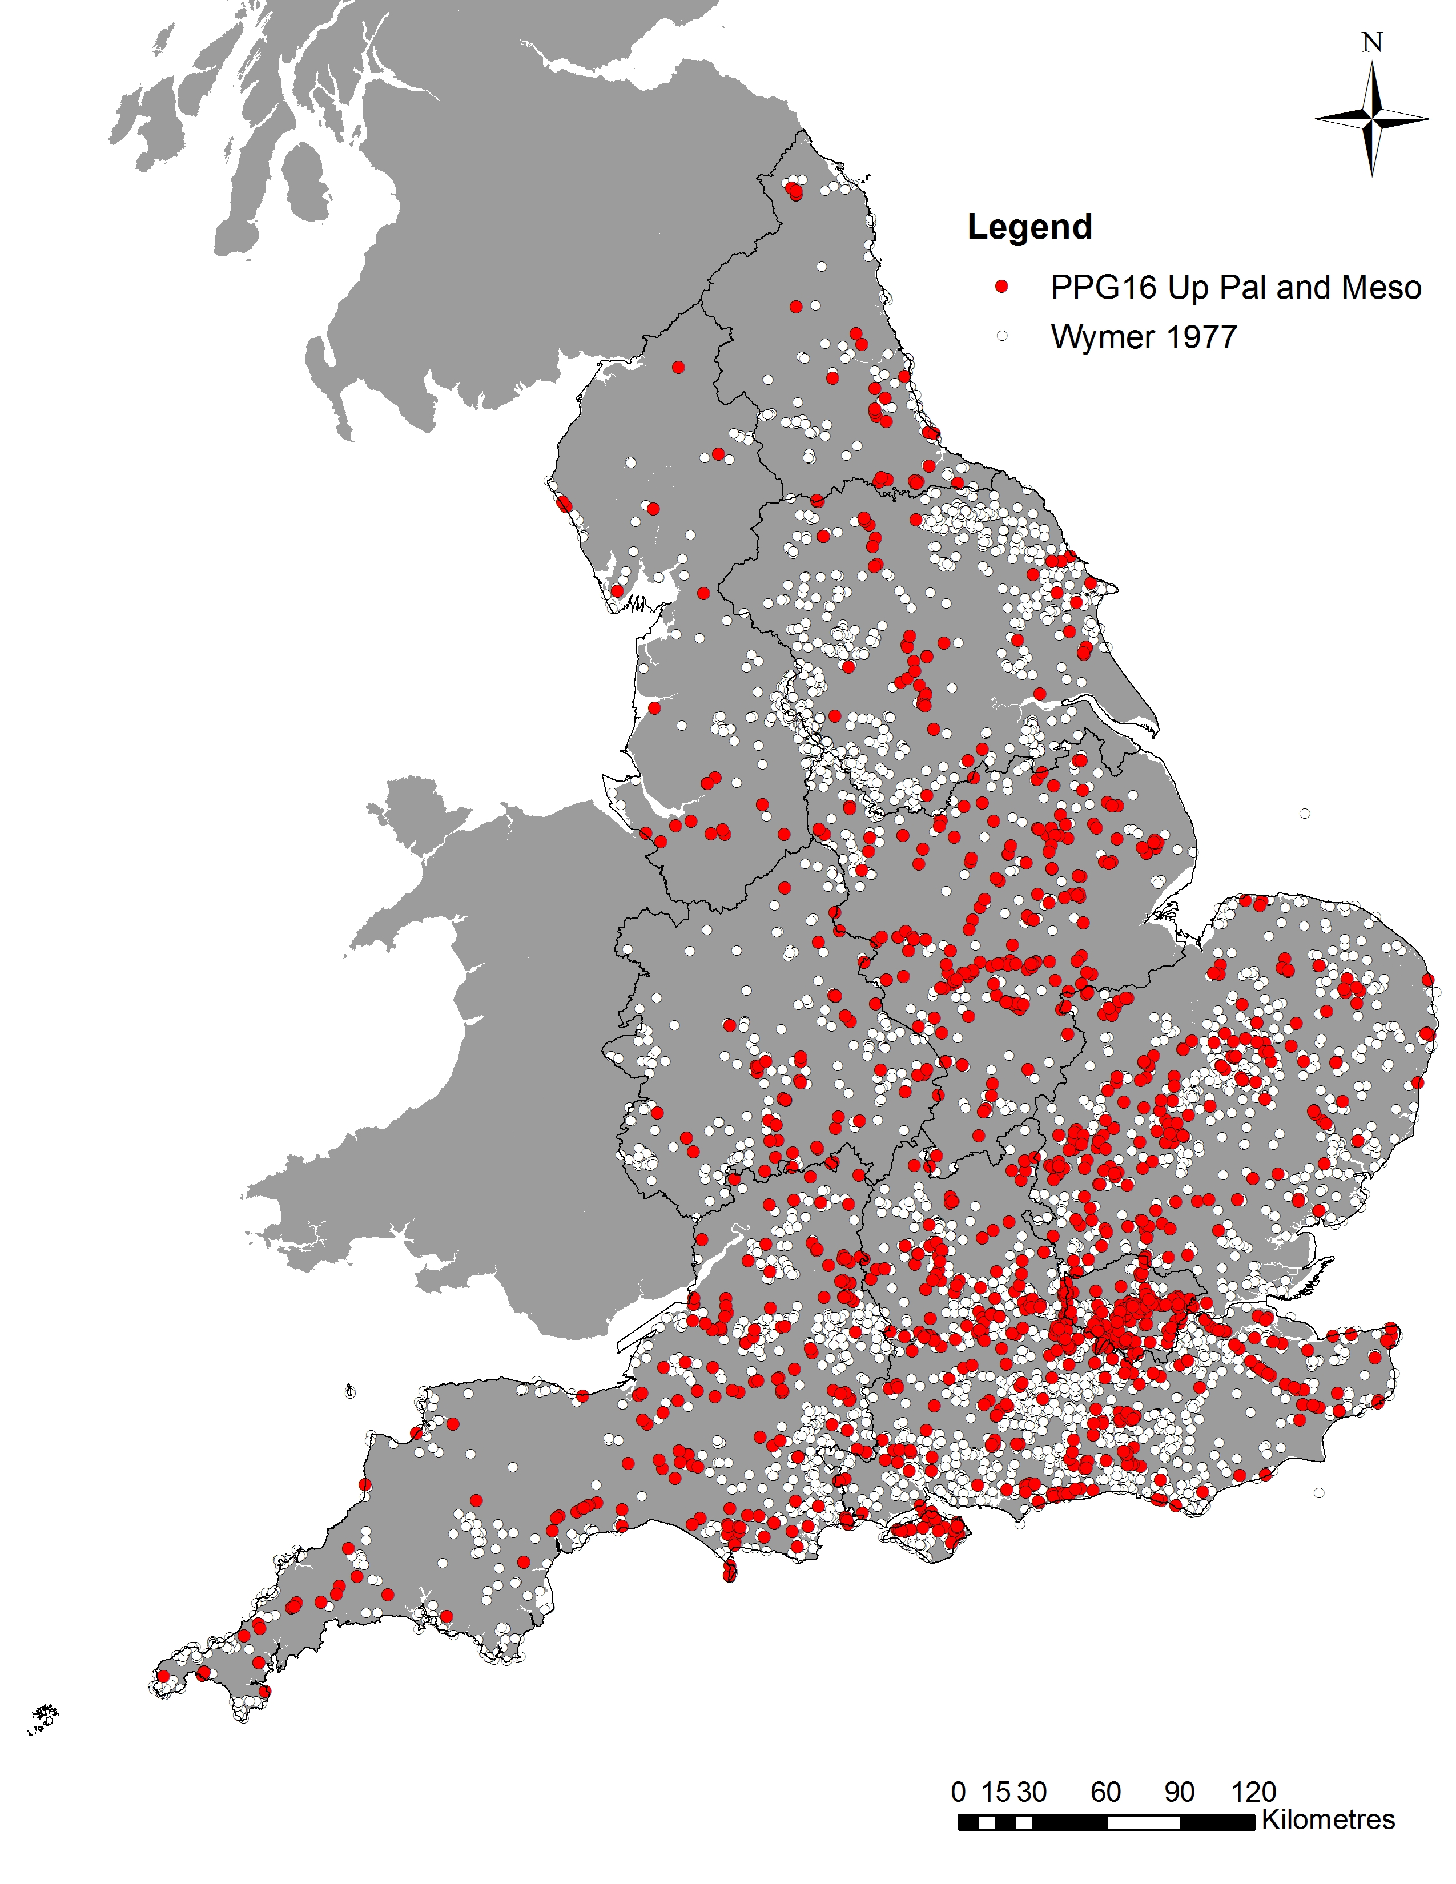
Fig. 7: Distribution of Late Upper Palaeolithic and Mesolithic sites: PPG16 era and Wymer 1977.
Regional Research Frameworks (RRF) discuss the significance of lithic sites and their importance in understanding the development of settlement patterns (https://historicengland.org.uk/research/support-and-collaboration/research-frameworks-typologies/research-frameworks/). RRFs include information which is useful for all stages of investigating lithic sites including DBAs and post-excavation assessments. They emphasise the strengths and weaknesses currently associated with the known lithic resource and advise on the work needed to enhance it, both for existing sites and for those discovered through commercial projects, for academic research and publicly funded projects. Given that the recommendations are built on research specific to each region they provide a benchmark from which the importance of sites, or a group of sites, can be assessed in relation to wider research objectives. These are often considered at a regional, national and international scale of significance.
At a regional level of significance, the analysis of a lithic site should add interpretative value towards understanding the development of local patterns of occupation within a particular chronological period or periods (Appendix 1: case study 2). At a national scale of significance, a lithic site should demonstrate a level of importance which benefits the broader understanding of the chronological development of themes relating to technological and social dynamics within the British Isles (Appendix 1: case studies 6 and 7). At an international level of significance, a lithic site will contribute to the interpretation of wider patterns of social networks and developments and will support and strengthen the existing knowledge of these. In this instance the site could be unique in terms of its value for understanding the chronological and technological developments of social organisation, activities and functions (Appendix 1: case study 9). In some circumstances it is possible that a lithic site will contribute to all three scales of significance.
In addition to the RRFs specific periods are also covered by research frameworks, including the Research and Conservation Framework for the British Palaeolithic (English Heritage 2008a, https://historicengland.org.uk/images-books/publications/research-and-conservation-framework-for-british-palaeolithic/palaeolithic-framework/) and the Mesolithic Research and Conservation Framework 2013 (Blinkhorn and Milner 2013, https://archaeologydataservice.ac.uk/researchframeworks/mesolithic/wiki/Meso_Res_Cons_Framework). These documents provide information on the current understanding of the period and research themes, agendas and strategies. As such, they provide sources of valuable information which can be used to define a Palaeolithic or Mesolithic site’s significance and value. The Lithic Studies Society’s publication Research Frameworks for Holocene Lithics in Britain (2008, http://www.lithics.org/wp/wp-content/uploads/2016/11/ResearchFrameworksForHoloceneLithicsInBritain.pdf) contains information, specific to the study of lithic artefacts, on research themes and strategies which are also useful for assessing the significance of lithic sites. In addition, further information on Palaeolithic sites will be available from the forthcoming Historic England guidance Curating the Palaeolithic.
Fieldwork evaluation approaches and techniques
Lithic sites can be the subject of further investigation within a development-led context or a research project. They can be an unexpected find during the course of ongoing fieldwork (Appendix 1: case study 6) and their discovery is often a cause of concern. The danger is that either their presence is unexpected and their potential is not realised against the backdrop of later archaeology, or alternatively the potential is realised too late in the archaeological process, raising concerns in terms of project delays and rising costs. Many recent discoveries of major lithic sites have highlighted the need to develop more robust and accurate methods for predicting and evaluating potential (Appendix 1: case studies 3, 6, 7 and 8).
Lithic sites are particularly problematic from a heritage resource and development management perspective, because evaluation techniques suited to identify lithic scatters like field walking and test pitting have been in decline since 1980’s, whilst less targeted approaches like the use of geophysics and trench evaluation has significantly increased in their application (Blinkhorn 2013). This trend has only been reversed in the last 15 years through the exponential growth of geoarchaeological deposit modelling and the use of more targeted evaluation approaches.
Archaeological interventions (trench evaluation, strip and record, and area excavation) can also actually result in the destruction of the resource — specifically in the case of scatters within active topsoils, buried soils or at the interface with the geology. This can either lead to an unquantified loss of important archaeological evidence, or the under-estimation of the magnitude of a site’s scale and importance, leading to missed research opportunities or, in a planning/development context, potentially avoidable expense, delay and inconvenience.
At present, there are no rigid methodologies in place for dealing with lithic sites, particularly surface scatters, in the planning process, and it is usually left to the discretion of individual Local Planning Authorities (LPAs) as to whether any form of evaluation and/or recording is undertaken post-determination (see section 3). Normally, methodologies for dealing with lithic sites would need to be established at the pre-determination stage of the planning process, as would those for sites which are discovered during archaeological evaluation and/or excavation.
For known lithic sites, there are a number of methodologies available which can be applied at various stages of prospection, evaluation and excavation (CIfA 2014b). These methodologies can be employed within development contexts, research-led projects and community-based investigations:
Prospection
- Monitoring, or the collection of data from, geo-technical investigations, often undertaken during the initial stages of a development, can inform on the geoarchaeological potential of a site and be used in the construction of a preliminary deposit models (see section 1; Appendix 1: case study 3). This type of investigation can be particularly useful where sediments are known to contain Palaeolithic sites or suspected, unknown lithic sites;
- Geoarchaeological investigation of buried environments using appropriate techniques in the form of augering, boreholes, test pitting and geophysical sediment mapping, in order to develop a sub-surface deposits model and predict areas and horizons with lithic potential that may require further investigation;
Evaluation
- Surface collection survey within the development or project area. The survey should include three-dimensional recording of finds using a Global Positioning System (GPS), in order to define issues such as the extent of the resource and the presence of discrete distributions of artefacts (Bayer et al. 2013), which could indicate the presence of buried structures or specific activity areas (Appendix 1: case studies 2, 4 and 5). Transect widths or grid size should be carefully considered in order to recover sufficient information to make an informed judgement on the size, technological composition and function of the lithic scatter (see section 3). This is of significance as research has identified that typically between one and five percent of a discrete scatter survives on the surface (Billington 2016). A good example of a fieldwalking survey coupled with sample test pitting (see below) undertaken on a large scale is the work of the Cambridge Archaeological Unit on the Cambridgeshire fenlands (Edmonds et al. 1999) and more recently by the Ice Age Journeys Community Archaeology Group at Farndon Fields, Newark (Garton et al. 2015);
- Sample test-pitting of the resource within the development or project area (Appendix 1: case study 2). This could be extended to large-scale test pitting of geological deposits where the potential for Palaeolithic activity has been predicted (Appendix 1: case study 7);
- Targeted sample sieving of topsoil or potential lithic-bearing deposits based on fieldwalking or geoarchaeological surveys, within the development area or project area (Appendix 1: case study 2). This could be implemented in tandem with other evaluation techniques, such as a test-pit survey or trial trenching;
- Technological analysis of the lithic material recovered during the application of the above survey techniques (Appendix 1: case studies 2, 4, 5, 6, 7 and 8). The results of the analysis should be produced as a report which details the physical quality of the struck lithics, technology and chronology. Report submission could be staged and used to inform the use of other evaluatory processes in a phased investigation.
Excavation
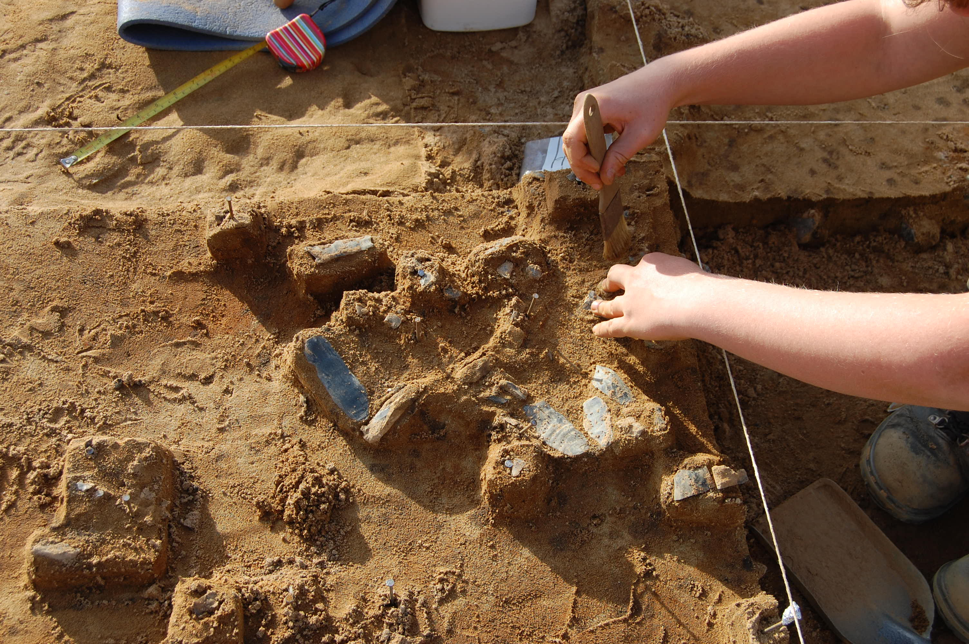
Fig. 8: High-resolution four-dimensional recording of an Upper Palaeolithic site at Guildford, Surrey. Each flint measuring greater than 10mm in maximum linear dimensions (MLD) had its 3D location and the angle of incline, in two directions recorded. This provides greater information on both formation processes and any post-depositional modification.
- In most development situations, for a variety of reasons the option to preserve a site in situ may not be viable and excavation is necessary (Appendix 1: case studies 6 and 7). Excavation is an approach to delivering public benefits which offsets harm done to the significance of heritage assets. It is important to note that excavation will often be applied to a site, or part of the site, located within the boundaries of the development and its ancillary works. When excavation is proposed a WSI pertinent to the site in question will be produced by the archaeological contractor (or the developer’s archaeological consultant), detailing the background, methods, and aims and objectives of the excavation.
- Excavation methodologies could include grid square excavation (Appendix 1: case studies 2, 6, 7 and 8) and/or the three/four-dimensional recording (ie recording the angle of incline, in two directions, of the object as well as the basic three dimensions) of artefacts (Figure 8); the sieving of spoil at an appropriate resolution (Appendix 1: case study 6 and 7); and ensuring a detailed understanding of the stratigraphy/site formation processes and the artefacts’ association with these (Appendix 1: case studies 3 and 8). It may be appropriate to contact a relevant lithic specialist during the formulation of the excavation methodology for advice on the lifting, handling and storage of artefacts for specialist study, such as microwear and residue analysis. As not all sites are the same, the methodology should be tailored to the site in question and have a clear set of aims and objectives in order to capture maximum information from the lithic resource.
Post-excavation
- Once excavation is complete the site archive generated during fieldwork should be the subject of a post-excavation assessment (PXA). In terms of the lithic assemblage, the PXA will recommend the analytical methodologies to be applied in its study (Appendix 1: case study 6). It is important to recognise that no two sites are the same and for this reason, and other factors (see the section on research above), the programme of analysis will vary from project to project. Nevertheless, the analysis will be geared towards answering specific research questions relating to the interpretation of the site: for example, understanding chronological developments; the sedimentary and palaeotopographic setting; the spatial organisation of activity; and raw material procurement strategies (Appendix 1: case studies 3, 6, 7 and 8). Integral to this is also the significance that the lithic assemblage and the associated site has in relation to wider research aims and objectives.
For dealing with previously unknown sites, elements of the methodologies proposed above could be implemented as and when the circumstances of discovery dictate. Additionally, landscape characterisation studies, predictive modelling and geoarchaeological deposit modelling could be implemented to lessen the risk of encountering unknown sites during evaluation in advance of development (see section 1; Appendix 1: case study 3), especially on sites where there is the potential for buried environments.
It is important to note that when applying any of the above methodologies they should be robust enough to produce a lithic assemblage of sufficient size to allow meaningful statements regarding the extent, technological composition, chronology and types of activity represented by the scatter to be made (Historic England 2018; see section 3; Appendix 1: case studies 1, 2, 4, 5, 6 and 7). Additionally, where previous investigation of the lithic resource has taken place it is important to consider the resolution of the previous sampling regime employed in relation to future investigations (Billington 2016). If it was applied on too large a scale it may have missed smaller sites or failed to define the full extent of the site, its chronological composition and function.
Analytical methodologies
Even though ploughzone lithic scatters are recovered from unsecure archaeological contexts they still warrant a certain level of analysis (see the introduction and section 1). This should include a technological assessment of the worked stone; an evaluation of the condition of the material and a study of its spatial composition and extent (Historic England 2018; Appendix 1: case studies 2, 4 and 5). Employing these criteria will allow a consideration of a lithic scatter’s importance, significance and landscape value (see section 1 and above). A technological assessment can range from quantification by lithic type to a detailed technological and attribute analysis of each piece of worked stone; however, sometimes, especially when a lithic assemblage comprises a large number of artefacts, detailed analysis is precluded by time and cost factors, particularly within a development context.
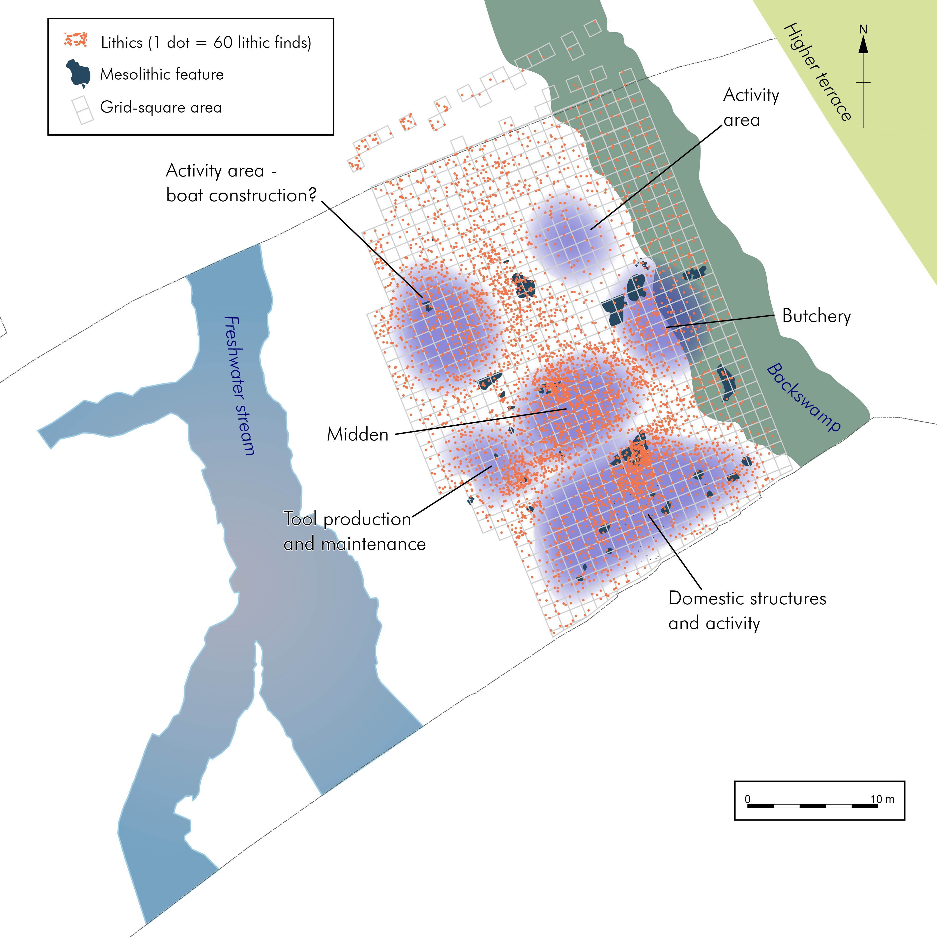
Fig. 9: Interpretive zones of late Mesolithic activity at Stainton West, Carlisle, based on the results of technological analysis, lithic spatial distribution and microwear study.
Lithic sites identified during excavation are, by their very nature, given heritage significance as a result of their archaeological interest. Due to their secure context and the fact that they are often associated with stratigraphic deposits, they are particularly responsive to vigorous analytical applications (Appendix 1: case studies 6, 7, 8 and 9; see Figure 9). However, it is important to realise that no two sites are the same, so not all analytical techniques are applicable to every site. Additionally, the value of analytical techniques should be proportionate to the significance of the site, and should be seen alongside other considerations such as research objectives set out in RRFs (see above; Appendix 1: case study 6), and the financial and time constraints of projects.
The use of the relevant analytical techniques will be defined in the lithic assessment report which forms part of the project PXA (see above). The lithic assessment provides an initial appraisal of an assemblage and usually includes a summary of its stratigraphic associations and spatial distribution; an assessment of its physical character, technological composition and integrity; a statement of potential for further analysis; and the costs involved in order to undertake the work. The assessment will also outline the analytical techniques that will be applied to enhance understanding of the assemblage. Occasionally, the potential of an analytical technique, such as microwear or protein residue analysis, will also be evaluated at the PXA stage in order to test for preservation and demonstrate its value in relation to the project’s research aims and objectives.
The project research aims and objectives will be formulated with reference to the relevant information set out in the RRF and the results of previous research (see above). In this way the value of the lithic assemblage can be defined with reference to its importance at a regional, national or international scale (see above), and the use of potentially expensive post-excavation analytical techniques in realising the significance of the site and ensuring public benefit can be justified (Appendix 1: case studies 6 and 7). The programme of analysis will be evaluated by the developer’s consultant, the archaeological contractor, heritage managers and other interested parties in relation to the project post-excavation budget and time scale.
Depending on the variables outlined above a number of techniques can be applied during the analysis of a lithic assemblage:
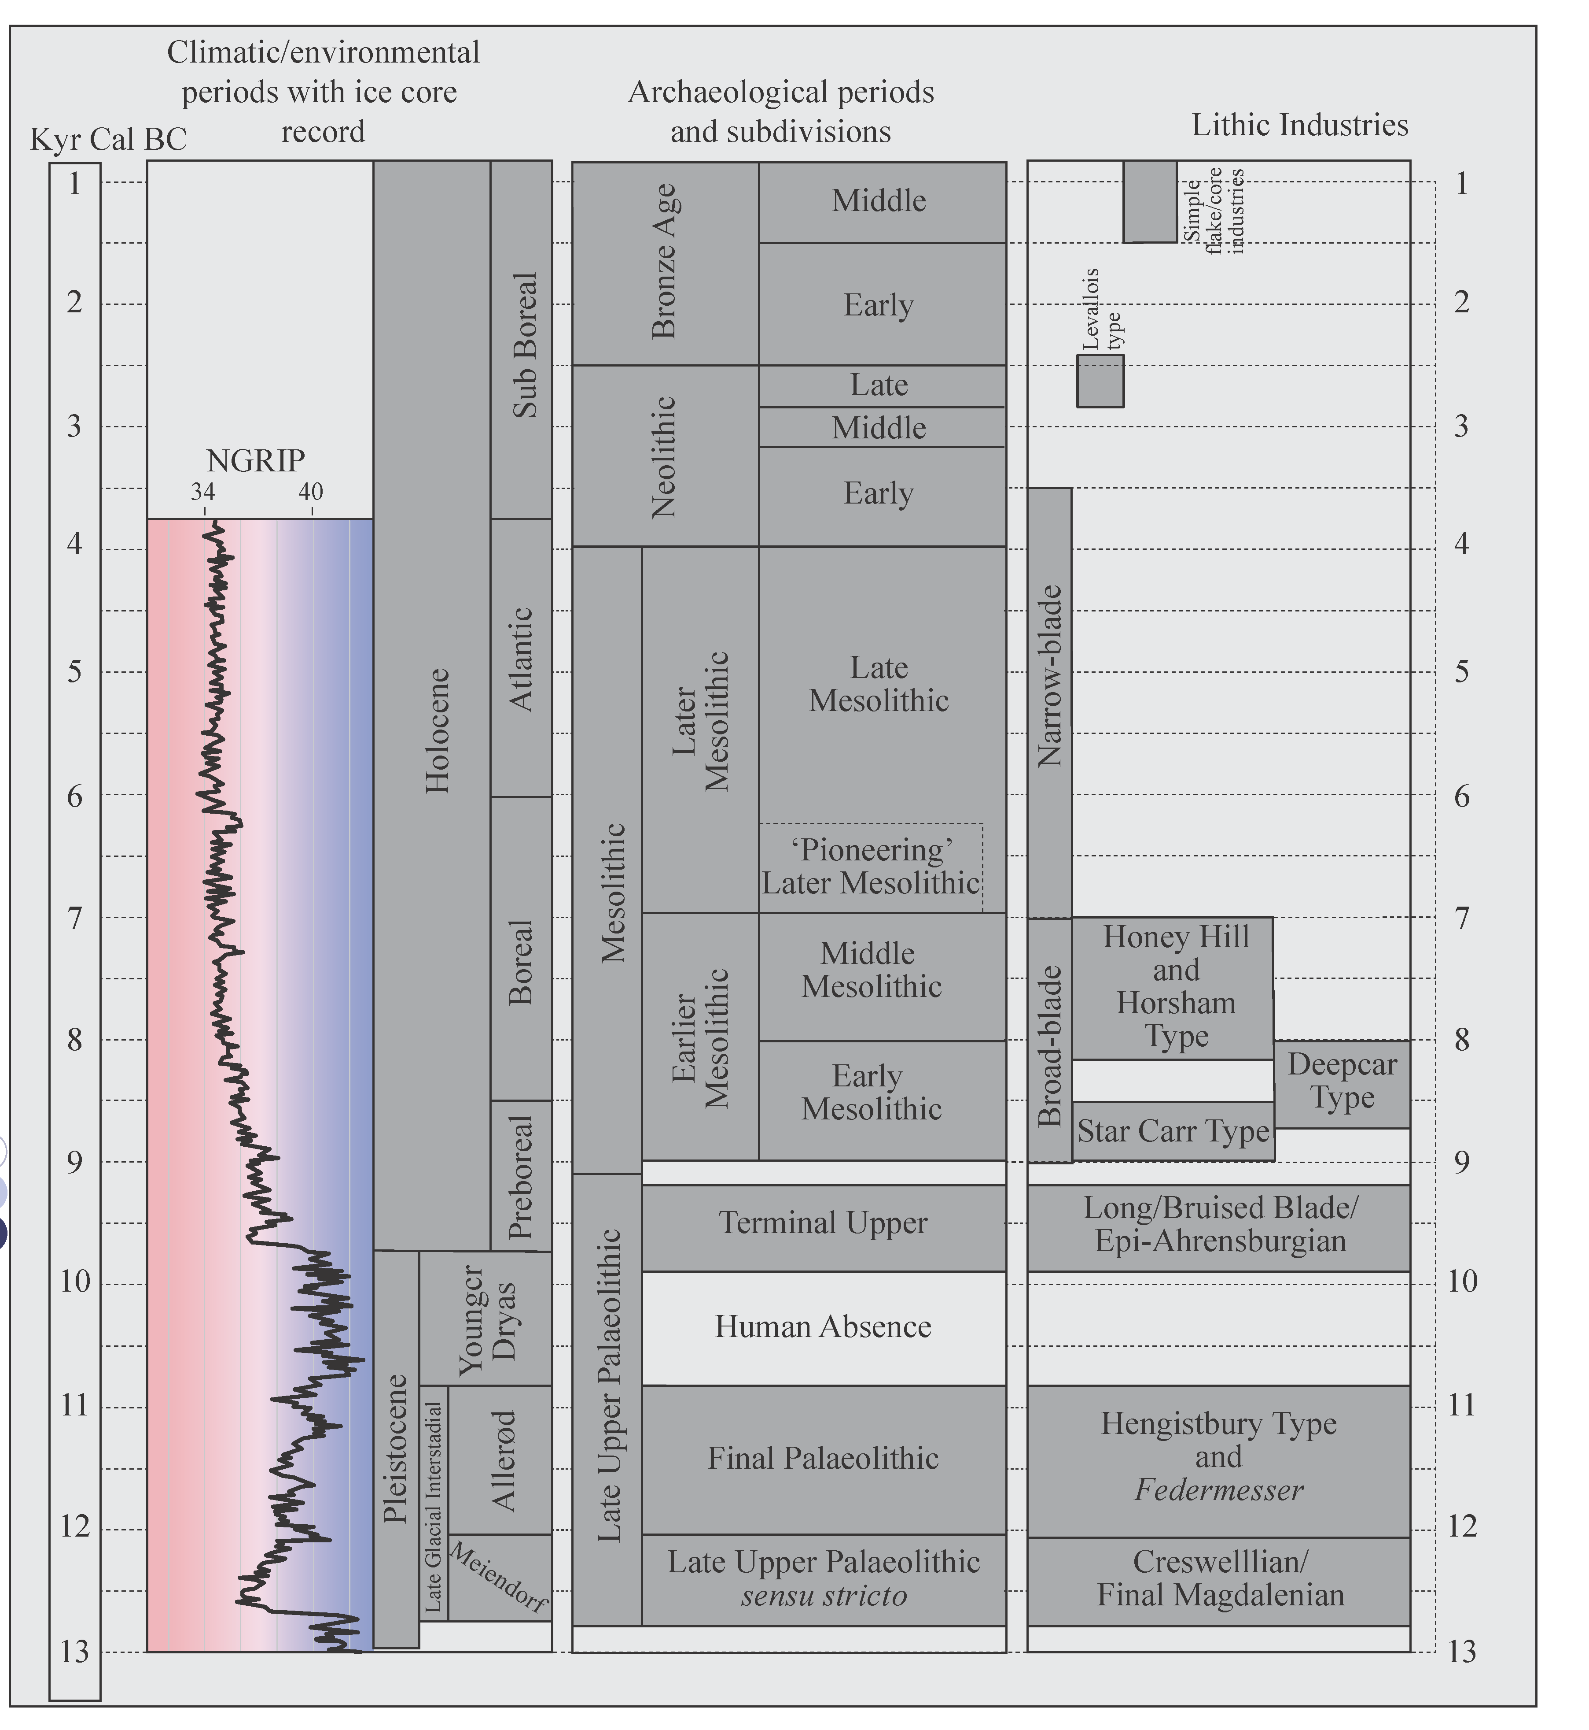
Fig. 10 Environmental and archaeological periods and associated lithic industries.
Technological analysis:
At the very least a lithic assemblage should be subjected to technological analysis (Appendix 1: case studies 2, 4, 5, 6, 7, 8 and 9). This identifies raw material types and records the metrical, typological and technological attributes of the assemblage in order to define its composition, date and function (Fig. 10). The results are often entered into the project database which can be queried in order to produce tables and charts which will be included in the lithic report. The report should also include scaled line drawings of selected lithics in order to support observations made in the text (Martingell and Saville 1988). When combined with other forms of analysis such as spatial analysis and microwear studies rich detail on the occupational activity at the site can be described.

Spatial analysis
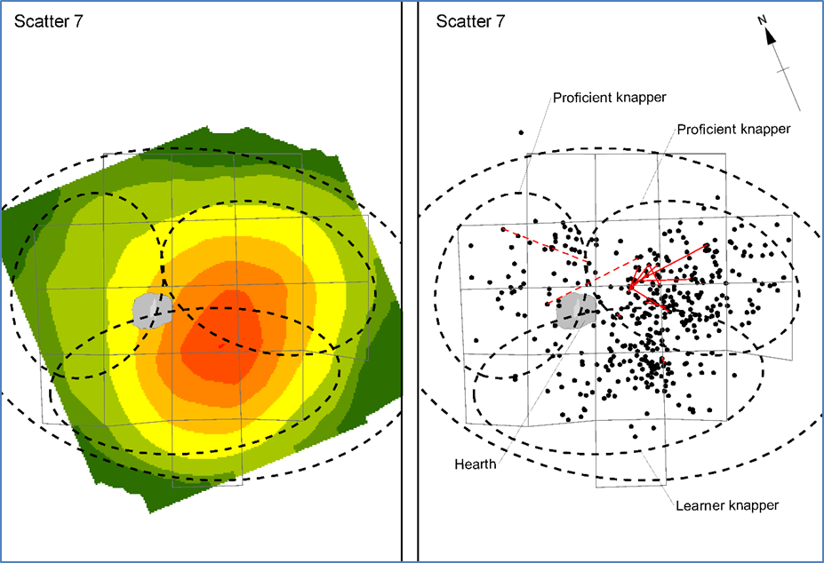
Fig. 11: Lithic distribution analysis showing an in situ lithic working surface with three knappers of different proficiencies working next to a central hearth from Bexhill to Hastings Link Road, East Sussex. Comparison of grid square recovery compared to 3D recording illustrates the effectiveness of spatial analysis depends on the type of recovery methodology employed during artefact collection. Both techniques provide useful spatial information in terms of the human activity that created the scatter, but the level of detail is directly related to the level of recording.
Spatial analysis has a wide range of uses in lithic analysis (Figure 11). In terms of lithic assemblages, the effectiveness of this type of analysis depends on the type of recovery methodology employed during artefact collection. This can range from the 3D recording of individual artefacts during fieldwalking surveys (Appendix 1: case studies 2, 4 and 5) to the 100% sample recovery of lithic material from a grid square excavation area which has been geographically located (Appendix 1: case studies 6, 7, 8 and 9). Lithic artefacts associated with 3D data can be plotted in Geographic Information Systems (GIS) and queried in order to understand densities and relationships between individual and/or groups of artefacts across a study area (Appendix 1: case studies 2, 6, 7, 8 and 9). Spatial analysis can also be used to investigate the wider landscape setting of a site in order to understand its context within regional settlement patterns and land-use strategies (Appendix 1: case studies 4 and 5).
Raw material sourcing: recent advances show that the geochemical analysis of lithic raw materials, and their cross-referencing with analogous geological samples, can be very useful in identifying distribution patterns of lithic sources and developing models of social interaction, not only at a site level but across regional and national landscapes (Appendix 1: case study 6). A variety of techniques can be applied to identify the geochemistry of lithic artefacts, including:
- Inductively Coupled Plasma Mass Spectroscopy (ICP-MS) and Inductively Coupled Plasma Optical Emission Spectroscopy (ICP-OES). These techniques involve the reduction of the artefact into a powder and are therefore destructive; however, Laser Ablation Inductively Coupled Plasma Mass Spectroscopy (LA-ICP-MS) is a similar technique which is non-destructive, although the results from LA-ICP-MS and ICP-MS and ICP-OES can be difficult to correlate;
- X-Ray Fluorescence (XRF) analysis. This technique is in its infancy and has some problems, but it is often undertaken in tandem with ICP-MS to refine the geochemical signature of archaeological and geological samples;
- Petrological thin section (PTS) analysis has been extensively applied in the sourcing of ground stone tools such as axe blades from the Central Lake District axe-production sites (Bradley and Edmonds 1993). XRF can also be used in tandem with PTS analysis to refine results.
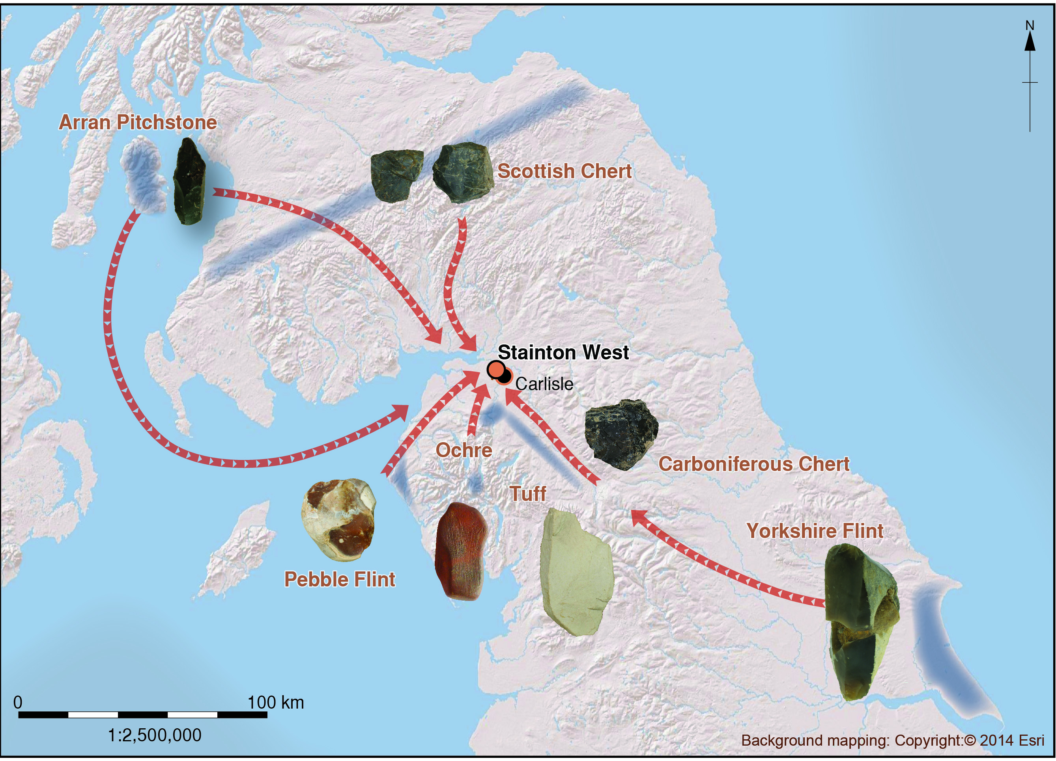
Fig. 12: The geographic distribution of lithic raw materials from Stainton West, Carlisle, Cumbria. The results of the geochemical analysis of archaeological lithic raw materials were cross-referenced with analogous geological samples in order to define procurement strategies at Stainton West. This identified that both local and non-local sources were used. The non-local sources included chert and pitchstone from Scotland and flint from east of the Northern Pennines. This pattern of procurement was initiated in the late Mesolithic and continued into the Neolithic indicating that the mechanisms involved in the movement of lithic raw materials endured for a long period of time (Brown et al. 2019).
Microwear analysis: comprises the microscopic identification of edge wear traces on stone tools and debitage. This analysis can be useful in identifying patterns of occupational activity across a site area. The results of microwear studies can be combined with those from technological analysis, residue analysis and spatial analysis to further define patterns of worked stone use (Appendix 1: case studies 6 and 7). The results from microwear studies can also be used to interpret site formation processes. It is important that advice on the lifting, handling and storage of artefacts is sought from a microwear specialist at an early stage in the excavation process. The wearing of powder-free sterile gloves during the lifting of artefacts, which should not be cleaned, and storing single items in appropriate bags will help to preserve wear traces until they reach the specialist.
Residue analysis: lithic artefacts can have remnants of residues adhering to their surface. In some instances, they relate to hafting technologies such as the use of birch bark tars, while in others they can be organic residues which relate to a stone tool’s use (Appendix 1: case study 6). Analysis such as gas chromatography-mass spectrometry (GS-MS) can define the organic nature of the residues and, if sufficient remains, these can be used for scientific dating. However, there is potential for contamination of the residues, so the implementation of appropriate methodologies for the lifting, handling and storage of artefacts should be ensured at an early stage in the excavation process (Högberg et al. 2009, 1728-9).
Protein residue analysis (PRA): also known as blood residue analysis, can also be used to collect information on tool and debitage use, diet and site function, and can be combined with microwear analysis (Högberg et al. 2009). For this to be effective artefacts have to be lifted during excavation in a block with a sample of the surrounding matrix and should not be subjected to cleaning. Again, the implementation of appropriate excavation techniques at an early stage in the project is important in order to recover, handle and store artefacts correctly.
Thermoluminescence (TL) dating: the direct scientific dating of burnt lithic samples is used to determine the time elapsed since the last firing of the material being studied (English Heritage 2008b, https://historicengland.org.uk/advice/technical-advice/archaeological-science/scientific-dating/; Barton et al. 2009). TL dating is often employed where the results of technological analysis cannot be used to define phases of occupation within a stratigraphic sequence and conventional means of scientific dating are unavailable. Thus the interpretation of the site within a chronological framework is limited. In this respect, TL dating is often applied during the study of complex Palaeolithic sites, particularly those associated with the Middle Palaeolithic period. Whilst this dating method undoubtedly has its value it also has problems, including the detection limits of the equipment used for very young samples and the saturation of the signal measured for very old samples.
Optically Stimulated Luminescence (OSL) dating can also be an effective means of direct dating of sediment contexts (and archaeological structures) containing certain types of minerals, which are associated with lithic artefacts (English Heritage 2008b). In contrast to TL dating OSL measures the energy emitted after a deposit has been exposed to daylight and then covered. Thus the stratigraphic layer in which the lithic artefacts have been identified is dated.
Refitting studies: this method comprises the refitting of lithic artefacts from the same reduction strategy or knapping episode (Appendix 1: case study 9). In most instances this usually constitutes the partial reconstruction of a manufacturing sequence or sequences (Figure 13). This technique usually involves the macroscopic inspection of lithic artefacts from an assemblage, but digital refitting is a recent development which can now be applied (http://fragmentedheritage.com/). Refitting not only allows lithic specialists to understand the technological character of an assemblage but can provide a wealth of information on archaeological site disturbance processes, modes of refuse accumulation and the occupational history of the site.
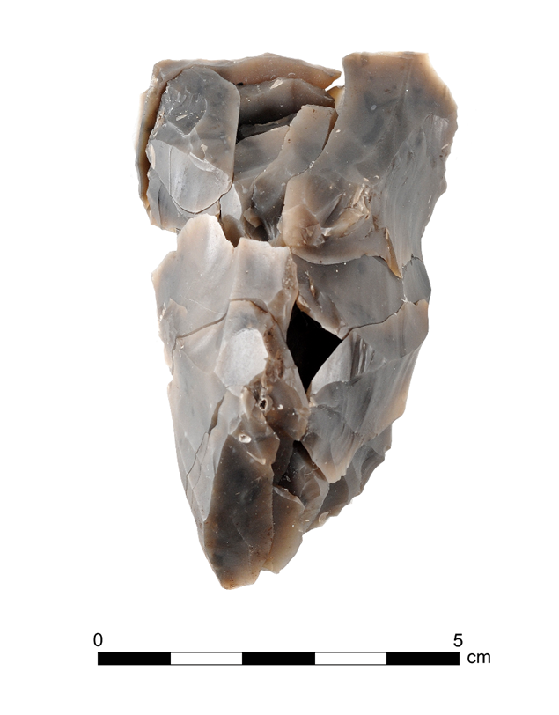
Fig. 13: An example of refitting an axe reworking/resharpening sequence from Star Carr. Refitting is a technique that has become a common tool in understanding lithic material. The technique is particularly favourable towards the study of lithics as knapping is a ‘subtractive technology’, and the manufacturing process can be reconstructed, and its spatial dimensions understood. The uses that refitting can be put to are numerous: it is an important tool for understanding site taphonomy, for unpicking palimpsests, for understanding techniques and both the social and spatial aspects of lithic technology and its organisation in the landscape (Appendix 1: case studies 7 and 9).
Statistical analysis: given that most lithic assemblages are partially representative of an activity or set of activities, the use of statistical models can provide a variety of additional information on the composition and function of the assemblage and/or its constituent parts (Appendix 1: case study 8). The statistical technique to be applied will depend on the questions being asked of the data set. Analyses can be used to identify specific artefact patterns across a site area, the identification of activities within a site and the relationship of a lithic artefact with other variables. For example, cluster analysis can be useful in determining spatial patterns between lithic types across the site area and also clarifying the potential variation in reduction schemas applied to different raw material types.

Management of lithic sites
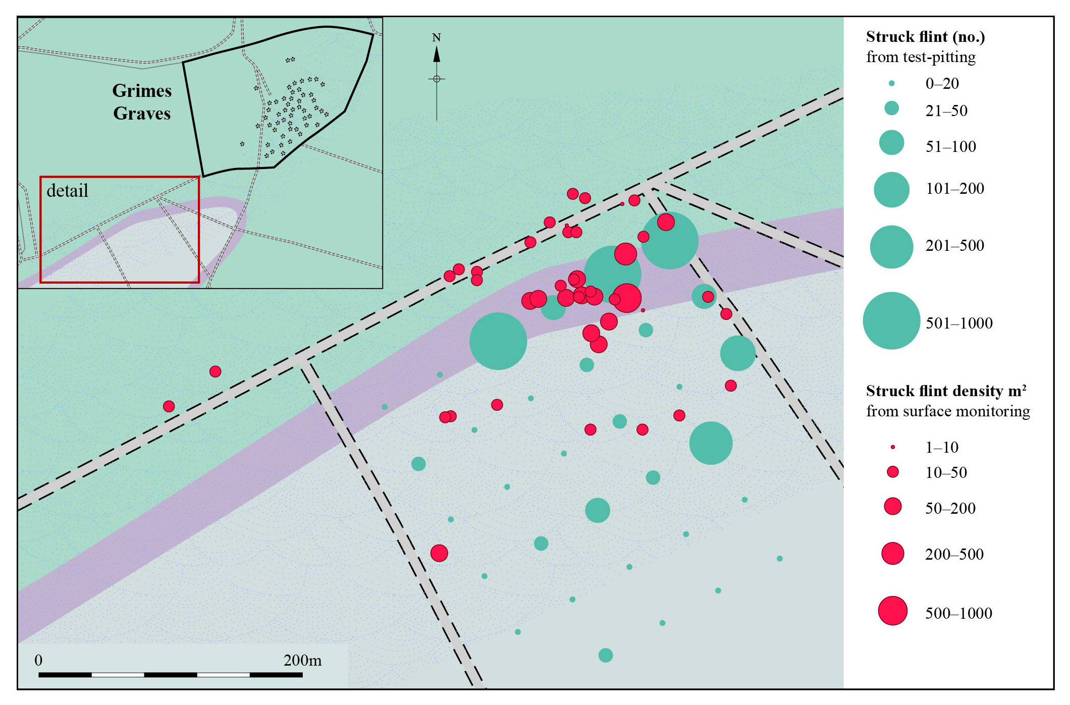
Fig. 14: Densities of struck flint from surface collection and test-pitting in the area around Grimes Graves. Highlighting the importance of examining monuments as part of a much wider landscape with both prominent and non-prominent zones of activity.
At present, lithic sites, particularly ploughzone surface scatters, generally cannot be scheduled under the terms of the 1979 Ancient Monuments and Archaeological Areas Act. Furthermore, lithic scatters are excluded from the Selected Heritage Inventory for Natural England (SHINE) on the basis that they do not fulfil the site selection criteria and the rules governing the application of agri-environment options. This stems from the fact that on the whole they are not designated as a significant resource, with ploughzone assemblages being seen as ‘sites without structures’ (Historic England 2018), thus making it difficult for LPAs to argue a case for their management.
In some particular instances mitigation measures and management proposals have been accorded to lithic sites under the terms of environmental stewardship agreements. For example, lithic scatters which have been identified through fieldwork and landscape characterisation and setting as having a spatial association with sub-surface features and wider heritage assets deemed of national importance have been taken out of development proposals and entered into a stewardship agreement. Under those terms, and in agreement with other interested parties, which can include LPAs and other heritage managers, the landowner is encouraged to enter into a long-term management plan. In a rural context management might include a scheme of reduced cultivation in order to diminish impact on the archaeological resource and promote preservation in situ. Some large-scale lithic sites, such as extraction sites (Figure 14), have also been identified as being of national importance. However, often the extent of extraction sites can make their wholescale management difficult to implement (Appendix 1: case study 5), and in some cases, such as the Central Lake District axe-production sites, they remain unscheduled. However, the site/s are covered by a Heritage Partnership Agreement (HPA). The HPA is a non-statutory agreement, which sets out an understanding of the significance of the heritage asset and serves as a management tool for the overall resource.
Guidance for the designation of national importance for lithic sites, but with particular relevance to lithic scatters, was initially published in Managing Lithic Scatters, where a list of six criteria was drawn up in order to assist in the identification of nationally important lithic scatters (English Heritage 2000, 7):
- Can the site's boundaries be identified?
- Does the quality/type of the artefacts from a recent collecting episode indicate that they were recently derived from sub-surface features?
- Has any additional investigative work been undertaken, which indicates the presence of structures?
- Does any part of the site remain undisturbed?
- Has any technological analysis been undertaken which can be used to date and interpret the site?
- Is there any diversity in technology and diagnostic artefact composition to indicate phases of repeated occupation and/or differences in activity?
It was proposed that any site fulfilling three of the criteria could be deemed of national importance. The Historic England updated guidance document, Sites of Early Human Activity; Scheduling Selection Guide (2018), argued that any site fulfilling four of the criteria should be considered of national importance. It also added an adjunct to the first criterion: the extent of a lithic site should be known in order to make it a discrete entity and it should be composed of a significant concentration of material.
In accordance with the NPPF (MHCLG 2018), non-designated heritage assets of archaeological interest which are demonstrably of equivalent significance to scheduled monuments (i.e. nationally important) should be considered subject to the same national planning policies as designated assets. The National Importance Programme was set up by English Heritage with representatives from English Heritage, the Association of Local Government Archaeological Officers (ALGAO) and the Department for Culture, Media and Sport (DCMS) to explore, via a series of pilot projects, how we might help create a shared understanding and mechanism to identify non-scheduled but nationally important archaeological sites (https://historicengland.org.uk/listing/what-is-designation/scheduled-monuments/national-importance-programme/). Of particular significance to the present guidance, three pilot projects were either specifically aimed at analysing aspects of national importance on lithic sites or included such sites within their remit.
A report on the identification and mapping of sites of national importance within the East Sussex wetlands (Oxford Archaeology 2015b, https://historicengland.org.uk/images-books/publications/identifying-and-mapping-sites-national-importance-east-sussex-wetlands/identifying-and-mapping-sites-wetland-environments-east-sussex-pilot-project-report/) proposed that nationally important sites which are not currently eligible for scheduling, including many early prehistoric sites such as lithic sites identified along wetland edges, should be highlighted as such in HERs. When threatened, the lithic sites should be evaluated through the planning process by pre-determination evaluation (see sections 1 and 2). A judgement could then be made on the heritage asset’s significance to determine if all or part of the asset is worthy of preservation in situ, as a site of national importance, or whether loss should be accepted and recording could constitute suitable mitigation.
A second project investigated how the significance of non-visible and ephemeral lowland Mesolithic sites of national importance is assessed and how they are mapped, with direct reference to a section of the Middle Kennet Valley in West Berkshire (Wessex Archaeology 2015, https://historicengland.org.uk/images-books/publications/early-mesolithic-wetland-sites-middle-kennet-valley/). Using a number of case studies from wetland areas, and a contrasting upland landscape, the project considered how to define, record and map sites and explored the role of the HER in these processes. It also proposed example methodologies for recording and defining sites and defining their group value through the application of GIS (see section 2). The analysis also considered mitigation of the resource against key risks by applying the then existing criteria for designation of general archaeological sites and lithic sites (see above) as being of national importance.
A third study assessed lithic sites, including scatters and extraction sites, in Cumbria and East Anglia. The project explored how lithic sites are presently ascribed archaeological significance, accordingly countenancing their suitability for inclusion in management plans, and summarised the existing measures available for designating the importance of lithic sites (Oxford Archaeology 2015a, https://historicengland.org.uk/images-books/publications/lithic-sites-assessment/lithic-sites-assessement/). This report considered several approaches that were integral to defining lithic sites as nationally important and the measures that would need to be taken to benefit those involved in the management of the resource. The report concluded that:
- effective approaches to defining the extent of lithic sites and areas of archaeological landscapes are critical for assessing the importance of the resource;
- discussions have served to highlight the complexity and difficulty inherent in the management of lithic sites and their designation as being of national importance through statutory or non-statutory processes;
- the present criteria and definitions used for assigning national importance to lithic sites need collating, updating and specifying.
Such measures would assist LPAs in the management of the lithic resource, whether that be a ploughzone surface scatter or an undisturbed site. At present LPAs are the main legislative organisations that can make the initial decisions relating to the mitigation and management of lithic sites, particularly in a development context. By flagging up the relevant records relating to lithic sites held in HERs at the pre-determination stage of a development proposal, LPAs can ensure that the information is used to assess the importance of the resource (see section 1). Once this is established LPAs can recommend evaluation to either assess the resource further and/or mitigate the impact from development in order to manage the resource effectively (see section 2).
The management and protection of lithic sites can sometimes be included in Environmental Stewardships, which are often coordinated beyond the remit of LPAs. Environmental Stewardship is a voluntary agri-environment scheme open to farmers across England, as part of the Rural Development Programme for England (Oxford Archaeology 2015b). In the design and implementation of agri-environment schemes, a balance is struck between wildlife, landscape, historic elements, public access, practical land management and agricultural factors. The avoidance of damage to the historic environment is a requirement of the scheme, and this includes heritage assets not specifically entered into the arrangement so should in effect provide protection of lithic sites. However, identification of most assets is based on the SHINE database, which does not currently include lithic scatters (see above), and if sites are unknown they have the potential to be subjected to further impact.

Further information
County-based data relating to information on archaeological sites and monuments are held in HERs or Sites and Monument Records (SMRs) and, for some historic towns, Urban Archaeological Databases (UADs) (see section 1). For lithic sites, the records can include a variety of information recovered from various forms of archaeological investigation including developer-funded evaluations (for example field walking and test pitting surveys, see section 2) and excavations, and academic and community-based research-led projects. Due to the circumstances of recovery those records often contain technological and spatial detail making them a valuable tool for research and management plans. HERs can also include reference to lithic assemblages collected by amateurs and antiquarian collections (Appendix 1: case studies 2 and 5). Often the vast majority of those records refer to single implements or small assemblages and have little associated spatial and technological detail, and some sites can be difficult to locate geographically. Nevertheless, they still have value for management purposes and often provide invaluable information for inclusion in broader research projects.
HERs are constantly being updated as new sites and monuments are identified and reported. In this way they should hold a relatively up-to-date record of lithic sites, including individual find spots, lithic scatters and excavated sites; nonetheless, it is essential to recognise that the records have limitations (Billington 2016; Appendix 1: case study 1). The quality of records varies between local authorities and reflects the record of archaeological investigation and data storage methods of particular offices. In some regions sites are ordered by period, but this may be misleading given that most lithic scatters can be representative of multiple phases of activity (see Introduction). In some cases, records refer to information from other sources which can be out of date. It is also important to consider that the lithic records held in many HERs relate to the research interests of local groups and individuals. They thus often relate to specific parts of the landscape and tend to reflect a biased site distribution, producing an unbalanced record of settlement activity. In this respect they are not an exhaustive record of lithic sites.
Lithic-related records held by HERs tend to have been generated over a long period of time and can contain inconsistences. Details are often partial or lacking, and sometimes even misleading. In this respect, the updating of HERs, where sufficient funds and resources have been made available, is an ongoing process. Historic England (English Heritage at the time of their implementation) have funded several projects designed to enhance the records held at a selection of county record offices (for example, Archaeological Services WYAS 2014, https://research.historicengland.org.uk/Report.aspx?i=15806). These were undertaken partly to benefit the development of mitigation strategies, but also to augment existing records and create new ones. Additionally, a project designed to assess the use of ploughzone data in development management, covering all types of artefacts and including lithic scatters, was conducted across a selection of HERs (Oxford Archaeology 2014, https://research.historicengland.org.uk/Report.aspx?i=15809). This survey highlighted the usefulness of ploughzone data, but also conceded that there is variability between HERs in how data are recorded and searched for, which can lead to sites being missed. The project also emphasised that some data, particularly those recovered from fieldwalking surveys and held by other organisations, are not always included on HERs. This emphasises the need to consult all sources relating to lithic sites, including that from development-led and research projects, in order to recover as much information as possible.
Portable Antiquity Scheme (PAS) database records are particularly associated with recording metal detecting finds, but they also contain records of other artefacts, including lithics. PAS database records are designed to be uploaded into HERs and provide another means of updating regional heritage records, broadening the pool of information on lithic sites by including data that may once have never reached HERS. As such, PAS provides a valuable source of information on lithic sites, though it has to be remembered that the bulk of the records comprise individual finds and small assemblages of artefacts (Bond 2010). However, the scheme also has some limitations. For example, the results of the ploughzone study (Oxford Archaeology 2014) identified that PAS information is not always integrated into HERs. Also, as the database was set up to record metal detecting finds, for security reasons find locations are often assigned grid references that relate to the south-east corner of the national grid square and this can be carried over to the HER. Therefore, the real location of some lithic sites may be lacking from the record.

Glossary of terms and meanings
Alluvium/alluvial: sedimentary deposits laid down through the action of water, such as in a floodplain environment.
Blade: debitage produced during knapping activity which has a length at least twice as long as its width.
Bronze Age: archaeological period spanning c 2500-800 BC. The early Bronze Age is characterised by a similar lithic technology to the preceding Neolithic period (see below). Barbed-and-tanged arrowheads replace forms that were prevalent in the Neolithic and the production of axes and other tools made from bronze becomes prevalent, but does not entirely replace the use of stone. Along with other monuments a variety of burial mounds, or barrows, were also constructed. During the late Bronze Age, the production of metal tools, weapons and ornamental items becomes more prevalent than in the earlier part of the period; stone is still used but the technology is characterised by the production of irregular flakes from which a restricted range of tools were made. Enclosed settlements and landscape division also become common.
Colluvium/colluvial: deposits associated with the movement of sediments downslope such as hill wash within a valley environment.
Core: a distinctive artefact that results from the practice of lithic reduction, by the detachment of one or more flakes from a lump of source material or stone tool.
Debitage: lithic waste material associated with the knapping of stone tools.
Designated heritage asset: scheduled monuments, listed buildings, conservation areas etc which have been identified as being of national importance and accorded legal protection.
Electro-magnetic (EM) Ground Conductivity Survey: a method that characterises the bulk geoelectric properties of near-surface sediments, and can be used on floodplain sites and other wetland environments to produce a high-resolution map of the different sediment zones and buried landscape features such as palaeochannnels and islands.
Flake: debitage produced during knapping activity which is broader than it is long.
Hunter-gatherers: people who collect and hunt natural resources such as berries, nuts, plants, fish and animals as part of their subsistence activities. In archaeological terms hunter-gatherers are pre-farming communities associated with the Palaeolithic and Mesolithic periods.
Geographical Information Systems (GIS): a system designed to capture, store, query and present spatial or geographic data.
Global Positioning System (GPS): a global satellite navigation system which records geolocation information to a GPS receiver.
Holocene: the current geological epoch which started after the last glaciation c 14,000 years ago.
Mesolithic: an archaeological period spanning c 10,000 to 4000 BC. Mesolithic communities practised hunter-gatherer subsistence strategies and relied on a specialised blade-based lithic technology mainly revolving around the production of small retouched tools known as microliths.
Microlith: a specialised form of Mesolithic tool usually made from snapping or segmenting blades. These are usually seen as composite tools for the creation of implements such as arrows, harpoons and fish spears. Useware analysis has shown that they have a wide range of functions including the processing of plants and animals.
Neolithic: an archaeological period spanning c 4000 to 2500 BC. Neolithic communities still utilised natural resources but also practised subsistence strategies associated with the cultivation of domesticated plants and the rearing of animals, and are recognised as the first farming groups. Blade-based lithic technologies are still used in the early Neolithic. In the later Neolithic they become increasingly focused on the production of flakes, from which a variety of tools were made, including single-piece arrowheads and spearheads and scraping tools. During this period monuments, such as causewayed enclosures, burial mounds and stone circles, were constructed and polished stone implements and ceramic vessels become widely used.
Palaeoenvironmental: relates to past environments and their study, and/or the analysis of preserved organic archaeological remains from archaeological deposits.
Palaeo-landsurface: former land surface which supported human activity which can often be found buried by sediments and/or peat and beneath certain types of monuments, such as burial mounds.
Palaeolithic: an archaeological period which in Britain runs from before 600,000 years ago to the beginning of the Holocene. In general terms, the Lower Palaeolithic is defined by handaxes, scrapers and utilised flakes. The Middle Palaeolithic tool kit includes handaxes, cleavers, points, scrapers, backed knifes and notches. The Upper Palaeolithic is divided into three phases (the Earlier Upper Palaeolithic, the Later Upper Palaeolithic and the Final Upper Palaeolithic) which are defined by different lithic facies, which share technological similarities with lithic assemblages from the continent. In general terms the Upper Palaeolithic includes a variety of tools comprising a series of points, scrapers, backed pieces, burins (a form of chisel or graver), piercers, notches, denticulates and, in the final stage, bruised blades.
Palimpsest: in relation to lithics describes an assemblage produced during different chronological phases which, due to the effects of a variety of natural and anthropogenic processes, has become intermixed; such assemblages have often lost their contextual integrity. The assemblage may represent activity from within the same archaeological period or from different periods, or a mixture of both.
Petrological thin section (PTS): small plug of material removed from stone tools, such as axe blades, which can be examined microscopically in order to define the geochemical composition of the raw material from which the tool was made. Comparison with thin sections from tools made from a similar lithology and analogous geological samples can potentially reveal the source area for the raw material.
Pleistocene: a geological epoch that began c 2.6 million years ago and stretched to the beginning of the Holocene. The epoch includes repeated glaciations and the Palaeolithic archaeological period.
Ploughzone: topsoil horizons which are predominantly the result of modern agricultural practices. In this respect they are created by ploughing and are continually being reworked. Ploughing effectively destroys in situ deposits at the interface between these deposits and the ploughzone, incorporating artefacts such as lithics into the topsoil horizon. Thus the objects lose their contextual integrity, effectively becoming a dispersed collection of artefacts.
Raw material: the material from which lithics are produced. In most regions of Britain flint is the predominant raw material utilised during stone working. However, in some areas of the country, for example in the north-west, where geological deposits containing flint are absent or inaccessible, there was a reliance on pebble flint from secondary deposits supplemented by other workable materials such as various types of chert, quartz and tuff.
Retouch: the working of the edge of an implement in order to make it into a functional tool, or to reshape a used tool.
Scraper: typically, a thick flake or blade used for processing hides and a range of other tasks, often using flakes from the initial stages of reduction.
Strip and record: a method of archaeological evaluation and/or excavation whereby a designated area, such as the footprint of a development, is stripped of topsoil deposits and/or other layers of overburden. The extent of any archaeological features revealed during this process are then mapped in order to produce a plan and sample excavated.
Trench evaluation: a method of archaeological evaluation usually involving the machine opening of a given number of trenches, of a predetermined size, covering an agreed sample area of a development. Features and deposits revealed within the trenches are characterised by hand excavation. This is undertaken in order to evaluate the presence/absence of archaeological deposits and define the function and date of any remains encountered, thereby providing a basis for decisions about the nature and scope of further work.
Walkover survey: in a commercial context this involves the physical archaeological examination of a development site at the pre-determination stage of enquiry, often in the context of preparation of a desk-based assessment. The survey is undertaken in order to identify, locate and record surviving earthwork features, including tracks and boundaries, and areas with palaeoenvironmental potential which may support evidence for archaeological activity.

Further reading
There is a wide range of literature available relating to the significance, evaluation, excavation and interpretation of lithic sites. Beyond those included in the bibliography of this guidance document a short but informative reading list is provided below:
Allen, T, 1998 Locating, evaluating and interpreting lithic scatters: the Eton Rowing Lake experience, Lithics 19, 33-46, available at http://journal.lithics.org/index.php/lithics/issue/view/43/showToc
Ballin, TB, 2017 Lithic assemblages. A guide to processing, analysis and interpretation, BAJR Guide 49, available at http://www.bajr.org/BAJRGuides/49_Lithics/49_Lithics_guide.pdf
CIfA 2014, Standard and guidance for the collection, documentation, conservation and research of archaeological materials, available at https://www.archaeologists.net/sites/default/files/CIfAS&GFinds_1.pdf
CIfA 2014, Standard and guidance for archaeological advice by historic environment services, available at https://www.archaeologists.net/sites/default/files/CIfAS&GArchadvice_2.pdf
Lisk, S, Schofield, J and Humble, J, 1998 Lithic Scatters after PPg16 – Local and national perspectives, Lithics 19, 24-32, available at http://journal.lithics.org/index.php/lithics/issue/view/43/showToc
Living with Monuments Project 2017 Excavations on Avebury Down, Avebury, Wiltshire, July-August 2017. An interim report, unpublished, available at https://ntarchaeostonehengeaveburywhs.wordpress.com/2018/02/15/foot-of-avebury-down-avebury-interim-report/
Pope, M, Bates, M, Blinkhorn, E, Connneller, C, Scott, B and Shaw, A, 2016 Excavation and Recording of Lithic Sites, produced by the La Manche Prehistoric research group for East Sussex County Council as part of the Sussex Archaeological Recording Standards, available at https://www.researchgate.net/publication/294891562_Advice_on_Excavation_and_Recording_of_Lithic_Scatters/download
A number of web sites also provide information on themes discussed in this guidance document:
https://historicengland.org.uk/research/agenda/thematic-strategies/
https://www.algao.org.uk/
https://www.forestry.gov.uk/fr/infd-5w2f23
http://www.lithics.org/
http://www.awrana.com/index.php?value=home
http://www.bajr.org/

Bibliography
Archaeological Services WYAS, 2014 Enhancing the Palaeolithic and Mesolithic Records of the South Yorkshire SMR, unpublished report
Barton, N, Ford, S, Collcutt, S, Crowther, J, Macphail, R, Rhodes, E and Van Gijn, A, 2009 A final Upper Palaeolithic site at Nea Farm, Somerley, Hampshire (England) and some reflections on the occupation of Britain in the Late Glacial Interstadial, Quartär 56, 7-35
Bayer, O, Barber, M and Wickstead, H, 2013 Damerham Archaeology project. EH Project Number 6800. Interim Report on Ploughzone Investigation in August 2013, unpublished report available at https://research.historicengland.org.uk/Report.aspx?i=15810
Billington, L, 2016 Lithic scatters and landscape occupation in the Late Upper Palaeolithic and Mesolithic: a case study from eastern England, unpublished PhD Thesis, University of Manchester, available at https://www.research.manchester.ac.uk/portal/files/54591471/FULL_TEXT.PDF
Blinkhorn, E and Milner, N, 2013 Mesolithic Research and Conservation Framework 2013, York, Council for British Archaeology
Bond, C J, 2010 The portable Antiquities Scheme: the contribution of lithics and lithic scatters, in S Worrell, G Egan, J Naylor, K Leahy and M Lewis (eds), A decade of discovery. Proceedings of the Portable Antiquities Scheme Conference 2007, Oxford, BAR British Series 520, 19-38
Bond, C J, 2011 The value, meaning and protection of lithic scatters, Lithics 32, 29-48
Bradley, R and Edmonds, M, 1993 Interpreting the axe trade: production and exchange in Neolithic Britain, Cambridge
Brown, F, Dickson, A and Evans, H, 2019 Crossing the divide: raw material use in the north-west of the British Isles in the Late Mesolithic and the Neolithic, in A Tether, P Topping and J Baczkowski (eds) Mining and Quarrying in Neolithic Europe: A Social Perspective, Oxford, Oxbow 149-162
Brown, F, Dickson, A, Gregory, R and Zant, J, forthcoming The archaeology of the Carlisle Northern Development Route
Butler, C, 2005 Prehistoric Flintwork, Tempus
Carey, C, Howard, A, Jackson, R and Brown, T, 2017 Using geoarchaeological deposit modelling as a framework for archaeological evaluation and mitigation in alluvial environments, Journal of Archaeological Science 11, 658-73
CIfA, 2014a Standard and guidance for historic environment desk-based assessment, available at http://www.archaeologists.net/codes/cifa
CIfA, 2014b Standard and guidance foe archaeological field evaluation, available at https://www.archaeologists.net/sites/default/files/CIfAS&GFieldevaluation_1.pdf
Chan, B T-Y, 2011 Stonehenge, looking from the inside out, a comparative analysis of landscape surveys, in A Saville (ed.), Flint and Stone in the Neolithic period, Oxford, Oxbow, 116-38
Conneller, C, Bayliss, A, Milner, N and Taylor, B, 2016, 'The Resettlement of the British Landscape: Towards a chronology of Early Mesolithic lithic assemblage types', Internet Archaeology, 42, available at https://doi.org/10.11141/ia.42.11
Edmonds, M, Evans, C and Gibson, D, 1999 Assembly and collection — lithic complexes in the Cambridgeshire fenlands, Proceedings of the Prehistoric Society 65, 47–82
English Heritage, 2000 Managing Lithic Scatters, London
English Heritage, 2008a Research and Conservation Framework for the British Palaeolithic, London
English Heritage, 2008b Luminescence Dating. Guidelines on using luminescence dating in archaeology, London
Garton, D, Baker, C, Banks, V, Barton, N, Budge, D, Collcutt, S, Price, S, Ross, I, Tapete, D and Tyndall, R, 2015 Ice Age Journeys: Research by a Community Archaeology Group at Farndon Fields, Newark, Nottinghamshire, Transactions of the Thoroton Society of Nottinghamshire, 119, 103-140
Harding, P, Ellis, C and Grant, M J, 2014 Late Upper Palaeolithic Farndon Fields, in N Cooke and A Mudd (eds), A46 Nottinghamshire. The archaeology of the Newark to Widmerpool Improvement Scheme, 2009, Cotswold Wessex Archaeology, 12-70
Historic England, 2015a Geoarchaeology. Using earth sciences to understand the archaeological record, Swindon, Historic England
Historic England, 2015b Managing significance in decision-taking in the historic environment. Historic environment good practice advice in planning: 2, Swindon, Historic England, available at https://historicengland.org.uk/images-books/publications/gpa2-managing-significance-in-decision-taking/
Historic England, 2017 The setting of heritage assets. Historic environment good practice advice in planning note 3 (second edition), Swindon, Historic England, available at https://historicengland.org.uk/images-books/publications/gpa3-setting-of-heritage-assets/
Historic England, 2018 Sites of Early Human Activity: Scheduling Selection Guide, Swindon, Historic England
Högberg, A, Puseman, K and Yost, C, 2009 Integration of use-wear with protein residue analysis – a study of tool use and function in the south Scandinavian Early Neolithic, Journal of Archaeological Science 36, 1725-37
Humphrey, J and Young, R, 1999 Flint use in later Bronze Age and Iron Age England — still a fiction? Lithics 20, 57-61
Inizan, M L, Roche, H and Tixier, J, 1992 Technology of knapped stone, Meudon, CREP
Last, J, 2009 Developing principles of selection for designating lithic scatters, unpubl rep
Lithics Studies Society, 2008 Research Frameworks for Holocene Lithics in Britain, London
Martingell, H and Saville, A, 1988 The illustration of lithic artefacts: a guide to drawing stone tools for specialist reports, available at http://www.gag-cifa.org/wp-content/uploads/2014/12/flint-paper-digital.pdf
Ministry of Housing, Communities and Local Government (MHCLG), 2018 National Planning Policy Framework, London, available at https://assets.publishing.service.gov.uk/government/uploads/system/uploads/attachment_data/file/740441/National_Planning_Policy_Framework_web_accessible_version.pdf
Oxford Archaeology, 2014 4G2 Ploughzone archaeology – historic environment record case studies: use of ploughzone data 6806, unpublished report
Oxford Archaeology, 2015a National Importance Programme: lithic assessment report 7046, unpublished report
Oxford Archaeology, 2015b National Importance Programme: identifying and mapping sites of national importance within the East Sussex wetlands, unpublished report
Oxford Archaeology, forthcoming Excavations on the Bexhill to Hasting Link Road, East Sussex
Wessex Archaeology, 2015 National Importance Programme: early Mesolithic wetland sites in the Middle Kennet valley, unpublished report
Wymer, J J, 1977 Gazetteer of Mesolithic sites in England and Wales, York, Council for British Archaeology

